|  |  |  |
| --- | --- | --- |
|  | **CAN THO UNIVERSITY SOFTWARE CENTER** |  |
| **MEKONG DELTA - APTECH** |

**Aptech Certified Computer Professional (ACCP)**

**SEMESTER IV**

**ZIP MART**

|  |  |
| --- | --- |
| **Instructor:** | **Class:**CP2396G01 |
| MSc. Lê Thị Minh Loan | **Team:** Group 05 |
| **Students:**  1. A21123 - To Quang Tuong  2. A21131 - Pham Hieu Tho  3. A21139 - Pham Huu Nhan |

Can Tho, 6 November 2023

This is to certify that

Mr: To Quang Tuong

Mrs: Pham Hieu Tho

Mr: Pham Huu Nhan

Has successfully Design & Developed

Submitted by: To Quang Tuong

Date of Issue: 21/12/2023



# PROBLEM DEFINITION OF PROJECT

Currently, in the dynamic e-commerce context, online supermarket systems have become an indispensable part of every person and modern lifestyle. Zip Mart is an online sales system that aims to target convenient shopping and at the same time provide some essential items.

However, there are still limitations that hinder optimal website performance and user experience as follows: The system still has errors and lacks information about some new products. The website does not fully cover sparsely populated areas and places without supermarkets, limiting customers' ability to search the website. For those users who are not artistically successful, it will be difficult to use the search interface and product details. After customers pay via bank accounts, the system is not secure enough to reveal personal information. The operating unit still has some limitations in the delivery process, but it is slow and ensures timely response, customers may encounter difficulties and discomfort during the receiving process.

Zip Mart is a system designed to involve buying and selling products via the Internet. The business process for the system is divided into 3 parts: client, customer and administration. Customers can visit the website, search, view product details, and cannot make online purchases. Customers after providing personal information such as address, account, phone number to become a member of Zip Mart. After logging in, customers can search for products based on criteria such as category, brand, price rating and product price. In addition, customers can add products to the cart and pay online using different methods such as credit cards or pay directly through the shipper. After completing the order, the system will transfer the order to the order history so the customer can evaluate the price and write comments about product satisfaction. The administrator has the right to manage user accounts including creating, updating and deleting accounts Admin can manage functions such as product categories, products, brands, orders. Additionally, administrators can still import goods into the warehouse.When it comes to major holidays and notable events of the administrator will create promotional coupons, discounts, give gifts to member users, manage membership levels, and accumulate rewards points. The administrator will create reports on revenue by day/month/year, revenue by efficiency, and revenue by category. In addition, the system should have a categorized menu, an attractive home page with attractive offers, and a page that includes the supermarket's address and contact information, and where product reviews can be submitted. of the purchased order. At the same time, customers can still learn or learn more about the cooking processes of dishes (recipes, cooking methods,. In short, the service process for our system is a comprehensive process so that customers have a convenient purchasing experience and administrators can manage the daily operations of the system.

# CUSTOMER REQUIREMENTS SPECIFICATION (CRS)

**Name of Project: Zip Mart**

1. **Modeling** **requirements of customer (Use case Diagram)**

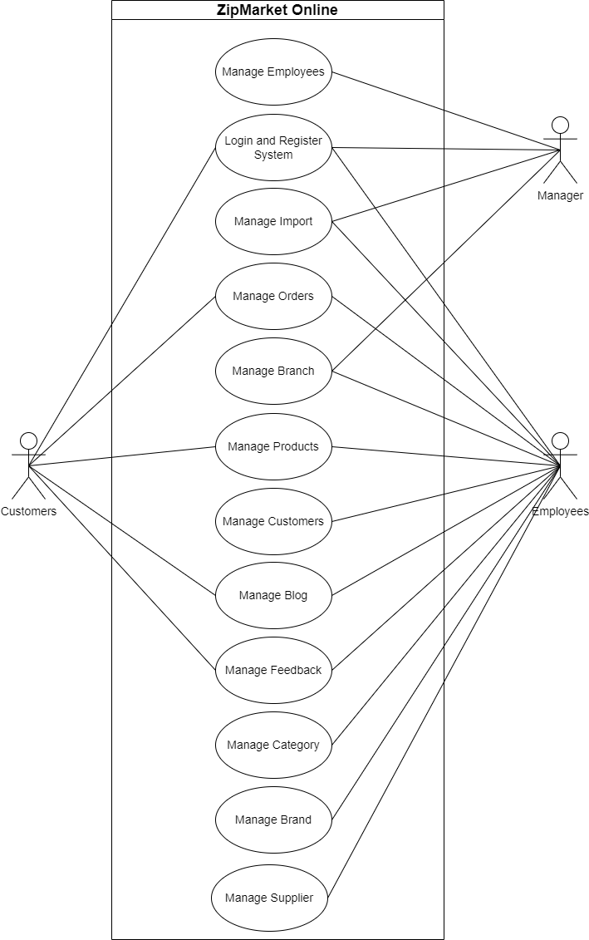

1. **Actor Description**

|  |  |  |  |
| --- | --- | --- | --- |
| **No.** | **Actor** | **Use case** | **Description** |
| **1** | **Customers** | View Products | Allows customers to view all products available in the store and detailed information of each product. |
| Create Orders | Allows users to select the products they want to buy in the shopping cart, create an order and make payment. |
| View Blog | Allows users to view blogs about daily menu topics... |
| View Feedback | Allows users to add, edit or delete their own feedback and view other users' feedback. |
| Login and Register | Allow Guests to log in with their registered account or register for an account if they do not have one. |
| **2** | **Manager** | Manage Employees | Allows managers to manage employees information including adding new employees, updating employees information, searching employees information and deleting employees. |
| Manage Import | Allows managers to manage import order information including viewing statistics import order information, and confirm status of import order.. |
| Manage Branch | Allows managers to manage branch information including adding new branch information, updating branch information, searching for branch information, and deleting branches. |
| Login Manager | Allows logging into the Manager's management system. |

|  |  |  |  |
| --- | --- | --- | --- |
| **3** | **Employees** | Login Employees | Allows logging into the Employees management system. |
| Manage Import | Allows managers to manage import order information including adding new import order information, updating import order information, view import order information and deleting import order information, statistics import order information. |
| Manage Order | Allows employees to manage order information including adding new order information, updating order information, searching for order information, review statistics, history ordered and deleting orders. |
| Manage Supplier | Allows employees to manage supplier information including adding new supplier information, updating supplier information, searching for supplier information, and deleting supplier. |
| Manage Customer | Allows employees to manage Customer information including adding new Customer information, updating Customer information, searching for Customer information and deleting Customer information. |
| Manage Blog | Allows employees to manage Blog information including adding new Blog information, updating Blog information, searching for Blog information and deleting Blog. |
| Manage Product | Allows employees to manage Product information including adding new Product information, updating Product information, searching for Product information and deleting Product. |
| Manage Feedback | Allows employees to manage Feedback information including see Feedback on each product and review statistics. |
| Manage Category | Allows staff to manage Category information including adding new Category information, updating Category information, searching for Category information and deleting Category. |
| Manage Brand | Allows employees to manage Brand information including adding new Brand information, updating Brand information, searching for Brand information and deleting Brand. |

1. **Use case Description**
2. **Manage Employees:** This module allows manager to information management of employees consisting of **adding new employee, updating information of employee, viewing employee information and deleting employee information.**

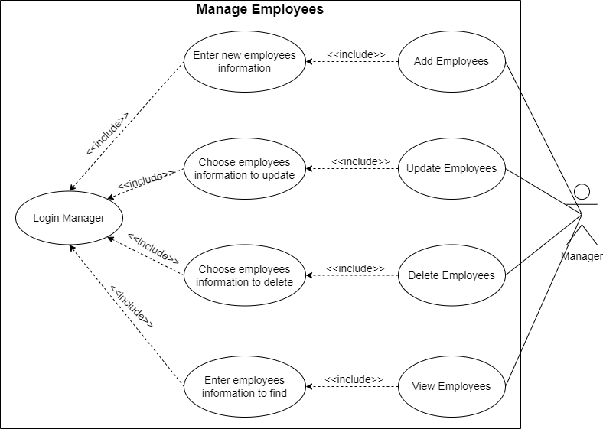

* 1. **Add Employees**
* **Purpose:** This module allows manager can add new employee information.
* **Input:**

+Id of employee

+ Name of employee

+ Address of employee

+ Phone of employee

+ Email of employee

* **Output:** New employee information is added to the table employees of the database.
  1. **Update Employees**
* **Purpose:** This module allows manager can update employee information.
* **Input:**

+ ID of employee

+ Name of employee

+ Address of employee

+ Phone of employee

+ Email of employee

* **Output:** Employee information is updated in the table employees of the database.
  1. **Delete Employees**
* **Purpose:** This module allows manager can delete employee information.
* **Input:** Empty
* **Output:** Employee information is deleted in the table employees of the database.
  1. **View Employees**
* **Purpose:** This module allows manager can view employee information and find employee information.
* **Input:** Name of employee.
* **Output:** Display employee information.

1. **Login and Register System:** This module allows manager, employees or customers **login** to website or allows customers can **register** account if they don’t have account.
   1. **Register**

* **Purpose:** This module allows customer register account as member of website.
* **Input:**

+ Username of customer

+ Password of customer

+ Confirm password

* **Output:** Notice of successful register and new information of customer account is added to table account in the database.
  1. **Login**
* **Purpose:** This module allows manager, employee, or customer login to website and use service.
* **Input:**
* Username
* Password
* **Output:** Notice of successful login and the system will redirect to index page depends on the logged user.

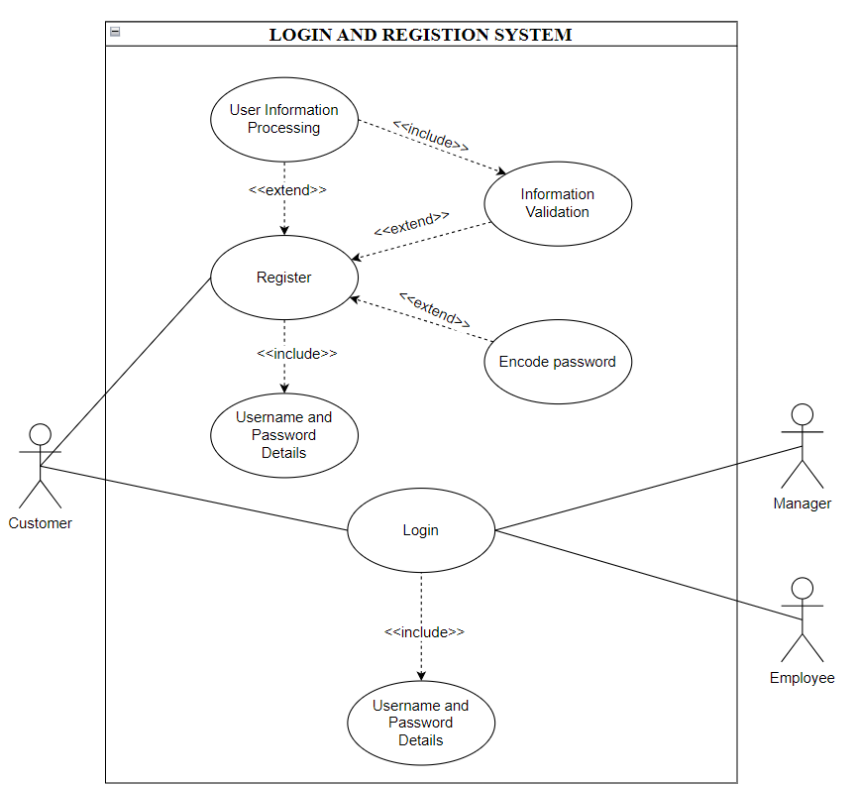

1. **Manage Import:** This module allows employees to information management of import consisting of **creating import order, updating import order information, deleting import order information, viewing import order information** and **creating statistics import order**. And allows manager can **confirm import order status** and **view statistics import order.**

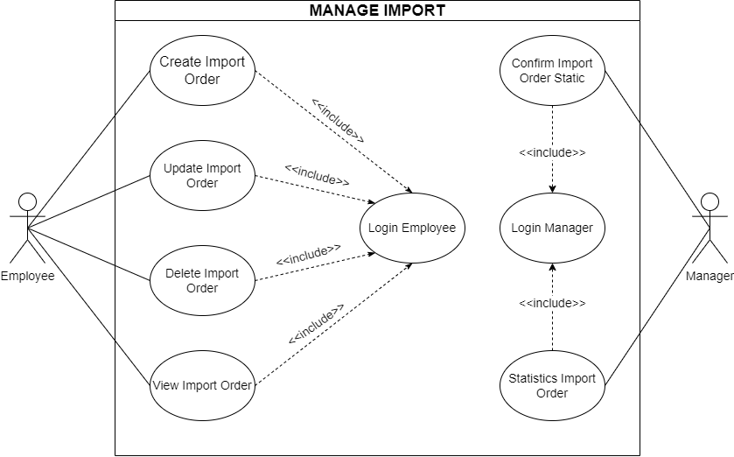

* 1. **Create Import Order**
* **Purpose:** This module allows employee can create new import order information.
* **Input:**

+ Import ID

+ Supplier ID

+ Brand ID

+ Name of product

+ Date import

+ Amount

+ HS code

+ Description

* **Output:** New import order information is added to the table import in the database.
  1. **Update Import Order**
* **Purpose:** This module allows employee can update import order information.
* **Input:**

+ Import ID

+ Supplier ID

+ Brand ID

+ Name of product

+ Date import

+ Amount

+ HS code

+ Description

* **Output:** Import order information is updated in the table import in the database.
  1. **Update Import Order**
* **Purpose:** This module allows employee can update import order information.
* **Input:**

+ Import ID

+ Supplier ID

+ Brand ID

+ Name of product

+ Date import

+ Amount

+ HS code

+ Description

* **Output:** Import order information is updated in the table import in the database.
  1. **Update Import Order**
* **Purpose:** This module allows employee can update import order information.
* **Input:**

+ Import ID

+ Supplier ID

+ Brand ID

+ Name of product

+ Date import

+ Amount

+ HS code

+ Description

* **Output:** Import order information is updated in the table import in the database.
  1. **Delete Import Order**
* **Purpose:** This module allows employee can delete import order information.
* **Input:** Empty.
* **Output:** Import order information is deleted in the table import in the database.
  1. **View Import Order**
* **Purpose:** This module allows employee can view and search import order information.
* **Input:** ID of import order.
* **Output:** The system will display list of import order information or display searchable import order information when employee search information.
  1. **View Import Order**
* **Purpose:** This module allows employee can view and search import order information.
* **Input:** ID of import order.
* **Output:** The system will display list of import order information or display searchable import order information when employee search information.
  1. **View Import Order**
* **Purpose:** This module allows employee can view and search import order information.
* **Input:** ID of import order.
* **Output:** The system will display list of import order information or display searchable import order information when employee search information.
  1. **Create Statistics Import Order**
* **Purpose:** This module allows employee can create statistics import order.
* **Input:** Empty.
* **Output:** The system will display detailed statistics of import order information.
  1. **Confirm Import Order**
* **Purpose:** This module allows manager can confirm status of import order.
* **Input:** Empty
* **Output:** The system will display status of import order, such as accepted order or rejected order.
  1. **View Statistics Import Order**
* **Purpose:** This module allows manager can view statistics of import order.
* **Input:** Empt
* **Output:** The system will display statistics of import order.

1. **Manager Orders:** This module allows employee to information management of order and customers can order product.

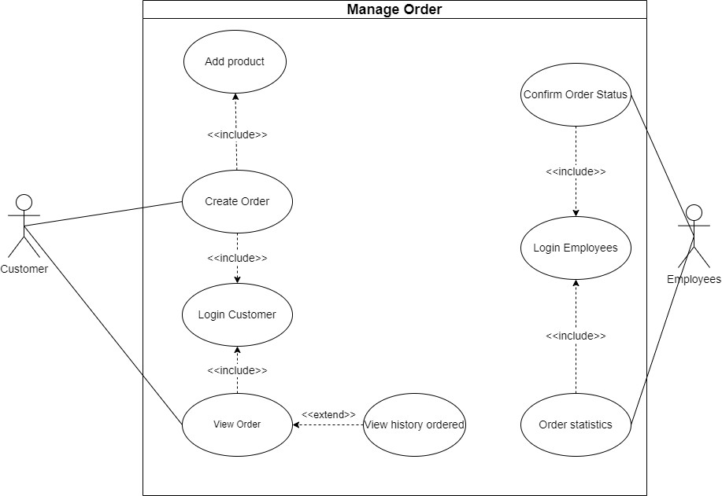

* 1. **Create Order**
* **Purpose:** This module allows customers selects the products they want to purchase and adds them to their cart. When they process to checkout and enter their shipping and billing information, the system will create an order for the customer.
* **Input:**

**+** Product ID

**+** Product Name

**+** Image

**+** Quantity of Product

**+** Unit Price of Product

**+** Total of price

**+** Customer information: This includes the customer's name, email address, shipping address, billing address, and payment information.

* **Output:**

**+** Order confirmation: This includes a summary of the order, such as the ordered products, quantity, price, shipping address, and expected delivery date.

**+** Payment confirmation: If the payment is successful, the customer will receive a confirmation message.

**+** Invoice: An invoice for the order will be generated and sent to the customer.

**+** Order status: The customer will be able to track the status of their order through the system.

**+** Inventory update: The system will update the inventory levels to reflect the sale of the products.

* 1. **View Order**
* **Purpose:** This module allows customer can view the details of any order they have placed, including the products ordered, the shipping and billing information and the order status.
* **Input:** Order ID
* **Output:**

+ Order details: This includes a comprehensive summary of the order, including:

+ Order ID

+ Date and time of order placement.

+ Customer information: This might include name, email, address, phone number.

+ List of ordered products with quantities and unit prices.

+ Subtotal, tax, and total amount.

+ Shipping method and estimated delivery date.

+ Payment method and status.

+ Current order status.

+ Links to download invoices or receipts.

+ Order history: The system might display a list of all the customer's previous orders for reference.

* 1. **View History of Ordered**
* **Purpose:** This module allows customer can views history of ordered and can re-order if they want.
* **Input:** Order ID
* **Output:** Display list of history ordered and the system provides the customer with a confirmation of the re-ordered and successful notification (if they want re-order).
  1. **Confirm Order Status**
* **Purpose:** This module allows employee can confirm the status of an order. The system will display the current status of the order, such as: “processing”, “accept order”, “decline order”, “pending payment”, “shipped”.
* **Input:** Empty
* **Output:** Display the order status on the order after confirmation.
  1. **Order Statistics**
* **Purpose:** The module allows employee can view statistics about order, such as: the number of the orders placed, the total revenue generated, and the most popular products.
* **Input:**

+ Date range filter (optional): The employee can specify a specific date range for the desired statistics. This allows for analyzing trends over time.

+ Product category filter (optional): The employee can filter the statistics by product category to gain insights into specific product performance.

+ Other filtering options (optional): The employee might have additional filtering options, such as revenue by day/month/year, number of products sold.

* **Output:**

+ Order count

+ Total revenue generated: The sum of all order amounts within the specified date range or filter criteria.

+ Average order value: The average amount spent per order within the specified date range or filter criteria.

+ Most popular products (optional): A list of the most frequently ordered products within the specified date range or filter criteria. This might be presented in various formats, such as:

+ Product name and quantity sold.

+ Revenue generated per product.

+ Percentage of total sales contributed by each product.

+ Product category performance: If a product category filter was applied, the system might provide specific statistics for each relevant category, including:

+ Number of orders within the category.

+ Total revenue generated by the category.

+ Average order value for the category.

+ Most popular products within the category.

1. **Manage Branch:** This module allows manager and employee to information management of branch consisting of **adding new branch, updating information of branch, viewing branch information, searching information of branch** and **deleting branch information.**

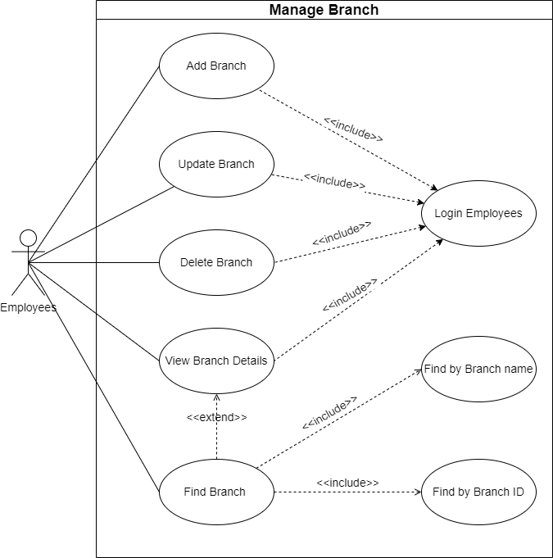

* 1. **Add Branch**
* **Purpose:** This module allows manager and employee can adding new branch information.
* **Input:**

+ Branch ID

+ Branch Name

+ Address of branch

+ Number phone of branch

+ Description about branch

* **Output:** New information of branch is added to the table branch of the database.
  1. **Update Branch**
* **Purpose:** This module allows manager and employee can update branch information.
* **Input:**

+ Branch ID

+ Branch Name

+ Address of branch

+ Number phone of branch

+ Description about

* **Output:** Branch information is updated in the table branch in the database.
  1. **Delete Branch**
* **Purpose:** This module allows manager and employee can delete branch information.
* **Input:** Empty.
* **Output:** Branch information is deleted in the table branch in the database.
  1. **View Branch Details**
* **Purpose:** This module allows manager and employee can view branch information.
* **Input:** Empty.
* **Output:** The system display list of branch information.
  1. **View Branch Details**
* **Purpose:** This module allows manager and employee can view branch information.
* **Input:** Empty.
* **Output:** The system display list of branch information.
  1. **View Branch Details**
* **Purpose:** This module allows manager and employee can view branch information.
* **Input:** Empty.
* **Output:** The system display list of branch information.
  1. **Find Branch**
* **Purpose:** This module allows manager and employee can find information of branch.
* **Input:**

+ ID of branch

+ Name of branch

* **Output:** The system will display searchable branch information.

1. **Manage Product:** This module allows employee to information management of product consisting of **adding new product, updating product information, view information of product, removing product information, searching product information** and **product statistics.**

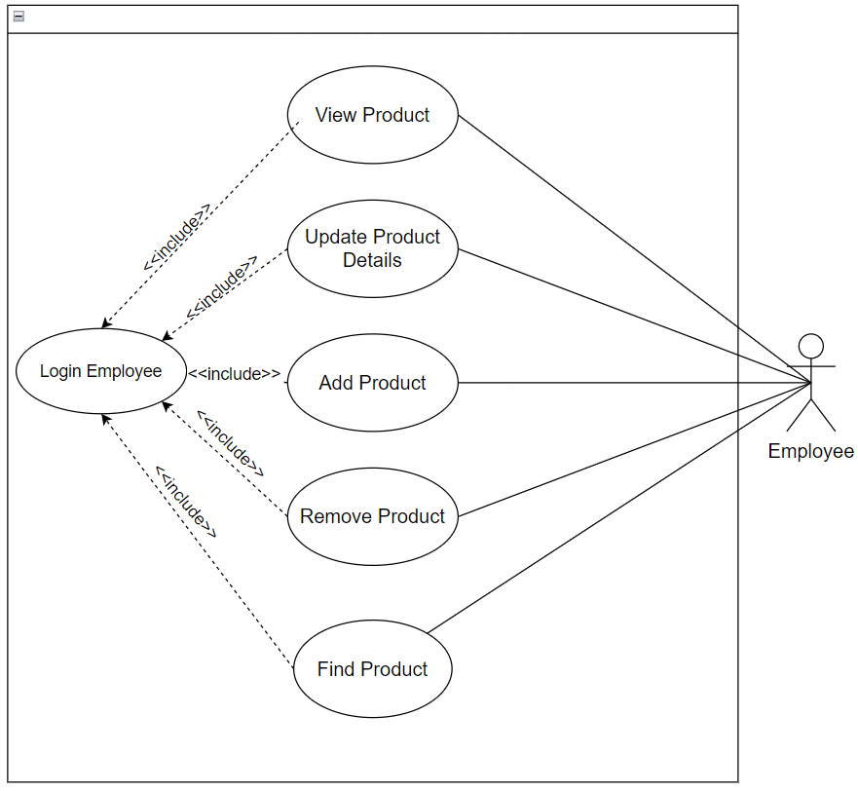

* 1. **Add Product**
* **Purpose:** This module allows employee can add new product.
* **Input:**

+ Product ID

+ Product Name

+ Image of product

+ Unit price of product

+ Quantity of product

+ Product unit

+ Description of product

* **Output:** New information of product is added to the table product in the database.
  1. **Update Product**
* **Purpose:** This module allows employee can update information of product.
* **Input:**

+ Product ID

+ Product Name

+ Category of product

+ Image of product

+ Unit price of product

+ Quantity of product

+ Product unit

+ Description of product

* **Output:** Product information is updated in the table product in the database.
  1. **View Product**
* **Purpose:** This module allows employee can view product information.
* **Input:** Empty.
* **Output:** The system will display list of product information.
  1. **Remove Product**
* **Purpose:** This module allows employee can delete product information.
* **Input:** Empty.
* **Output:** Product information is deleted in the table product in the database.
  1. **Find Product**
* **Purpose:** This module allows employee can search product information.
* **Input:**

+ ID of product

+ Name of product

+ Brand of product

+ Supplier of product

* **Output:** The system will display searchable information of product.

1. **Manage Customers:** This module allows employees to information management of customer consisting of **adding new customer information, updating information of customer, viewing customer information, searching information of customer,** and **deleting customer information.**

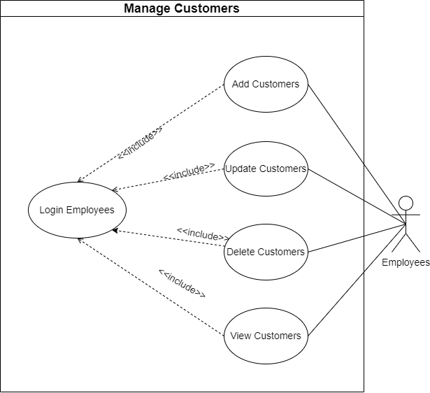

* 1. **Add Customer**
* **Purpose:** This module allows employee can add new information about customer.
* **Input:**

+ Customer ID

+ Customer name

+ Address of customer

+ Number phone of customer

+ Email of customer

+ Information of credit card (such as: card number, card name, from value, expiration date, cvv number).

+ Rank of customer

* **Output:** New information of customer is added to the table customer in the database.
  1. **Update Customer**
* **Purpose:** This module allows employee can update customer information.
* **Input:**

+ Customer ID

+ Customer name

+ Address of customer

+ Number phone of customer

+ Email of customer

+ Information of credit card (such as: card number, card name, from value, expiration date, cvv number).

+ Rank of customer

* **Output:** Information of customer is updated in the table customer in the database.
  1. **Delete Customer**
* **Purpose:** This module allows employee can delete customer information.
* **Input:** Empty
* **Output:** Customer information is deleted in the table customer in the database.
  1. **View Customer**
* **Purpose:** This module allows employee can view information of customer.
* **Input:** Empty
* **Output:** The system will display list of customer information.
  1. **Find Customer**
* **Purpose:** This module allows employee can search information of customer.
* **Input:** Name of customer.
* **Output:** The system will display searchable of customer information.

1. **Manage Blogs:** This module allows employee to information management of blog consisting of **adding new blog, updating blog information, viewing blog, searching blog information** and **deleting blog information.**
   1. **Add Blog**

* **Purpose:** This module allows employee can add new blog information.
* **Input:**

+ ID of blog

+ Title of blog

+ Image of blog

+ Content of blog

* **Output:** New blog information is added to table blog in the database.
  1. **Update Blog**
* **Purpose:** This module allows employee can update blog information.
* **Input:**

+ ID of blog

+ Title of blog

+ Image of blog

+ Content of blog

* **Output:**  Information of blog is updated in the table blog in the database.
  1. **Delete Blog**
* **Purpose:** This module allows employee can delete blog information.
* **Input:** Empty
* **Output:** Blog information is deleted in the table blog in the database.
  1. **View Blog**
* **Purpose:** This module allows customer can view blog information.
* **Input:** Empty
* **Output:** The system will display blog information.
  1. **Find Blog**
* **Purpose:** This module allows customer can search blog information.
* **Input:** Title of blog.
* **Output:** The system will display result of search blog information.

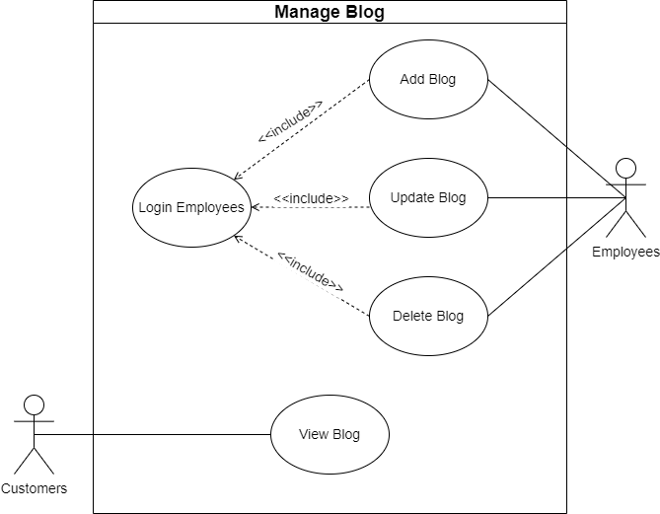

1. **Manage Feedbacks:** This module can allow customers to leave their feedback about the product including **adding feedback**, **updating feedback**, **deleting feedback**, and employees have the right to manage feedback including **searching for feedback**, **deleting feedback** if necessary and collecting **feedback statistics**.

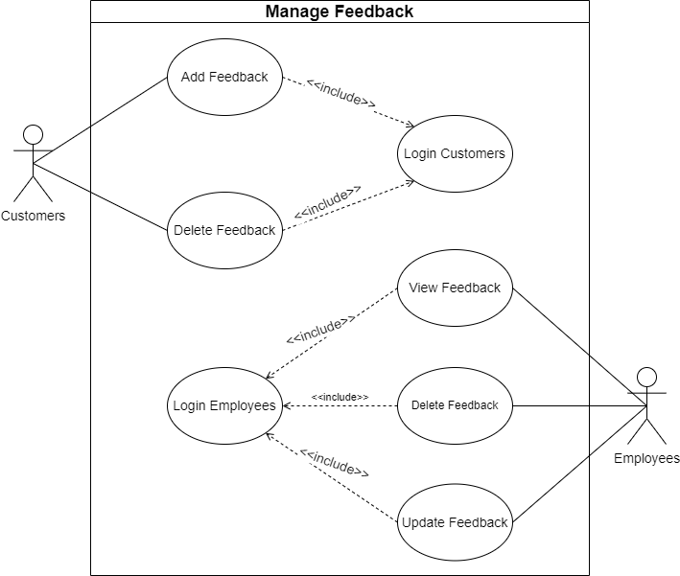

* 1. **Add Feedback**
* **Purpose:** This module allows customer can add new feedback information.
* **Input:**

+ID of feedback

+ Title of feedback

+ Content of feedback

+ Rate of feedback

+ Feedback date

* **Output:** New information of feedback is added to table feedback in the database.
  1. **Delete Feedback**
* **Purpose:** This module allows customer can delete feedback information.
* **Input:** Empty
* **Output:** Feedback information is deleted in the table feedback in the database.
  1. **Find Feedback**
* **Purpose:** This module allows employee can search feedback information.
* **Input:** Rate of feedback
* **Output:** The system will display searchable feedback information.
  1. **Statistics Feedback**
* **Purpose:** This module allows employees to see their satisfaction level with each product.
* **Input:** Empty.
* **Output:** The system will display rate accompanying user comments about each product.

1. **Manage Category:** This module allows employee to information management of category consisting of **adding new category, updating category information, viewing category information, searching information of category,** and **deleting category.**

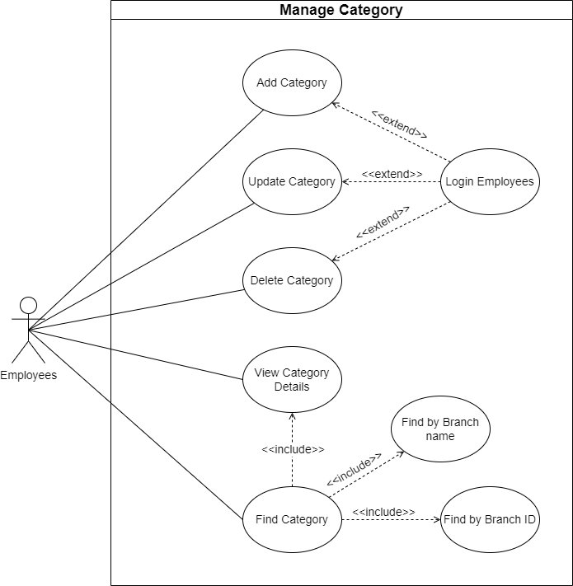

* 1. **Add Category**
* **Purpose:** This module allows employee can add new category information.
* **Input:**

+ ID of category

+ Name of category

+ Description of Category

* **Output:** New information of category is added to the table category in the database.
  1. **Update Category**
* **Purpose:** This module allows employee can update category information.
* **Input:**

+ ID of category

+ Name of category

+ Description of category

* **Output:** Category information is updated in the table category in the database.
  1. **Delete Category**
* **Purpose:** This module allows employee can delete category information.
* **Input:** Empty
* **Output:** Category information is deleted in the table category in the database.
  1. **View Category**
* **Purpose:** This module allows employee can view category information.
* **Input:** Empty.
* **Output:** The system will display list of category information.
  1. **Update Category**
* **Purpose:** This module allows employee can update category information.
* **Input:**

+ ID of category

+ Name of category

+ Description of category

* **Output:** Category information is updated in the table category in the database.
  1. **Update Category**
* **Purpose:** This module allows employee can update category information.
* **Input:**

+ ID of category

+ Name of category

+ Description of category

* **Output:** Category information is updated in the table category in the database.
  1. **Delete Category**
* **Purpose:** This module allows employee can delete category information.
* **Input:** Empty
* **Output:** Category information is deleted in the table category in the database.
  1. **View Category**
* **Purpose:** This module allows employee can view category information.
* **Input:** Empty.
* **Output:** The system will display list of category information.
  1. **Find Category**
* **Purpose:** This module allows employee can search category information.
* **Input:**

+ ID of category

+ Name of category

* **Output:** The system will display searchable category information.

1. **Manage Brand:** This module allows employee to information management of brand consisting of **adding new brand information, updating brand information, deleting brand information and view brand information.**
   1. **Add Brand**

* **Purpose:** This module allows employee can add new brand information.
* **Input:**

+ ID of brand

+ Name of brand

+ Address of brand

* **Output:** New information of brand is added to table brand in the database.
  1. **Update Brand**
* **Purpose:** This module allows employee can update brand information.
* **Input:**

+ ID of brand

+ Name of brand

+ Address of brand

* **Output:** Information of brand is updated in the table brand in the database.
  1. **Delete Brand**
* **Purpose:** This module allows employee can delete brand information.
* **Input:** Empty.
* **Output:** Brand information is deleted in the table brand in the database.
  1. **Delete Brand**
* **Purpose:** This module allows employee can delete brand information.
* **Input:** Empty.
* **Output:** Brand information is deleted in the table brand in the database.
  1. **View Brand**
* **Purpose:** This module allows employee can view brand information and search information of brand.
* **Input:**

+ Name of brand

+ Address of brand

* **Output:** The system will display list of brand information or display searchable information of brand when employee find brand information.

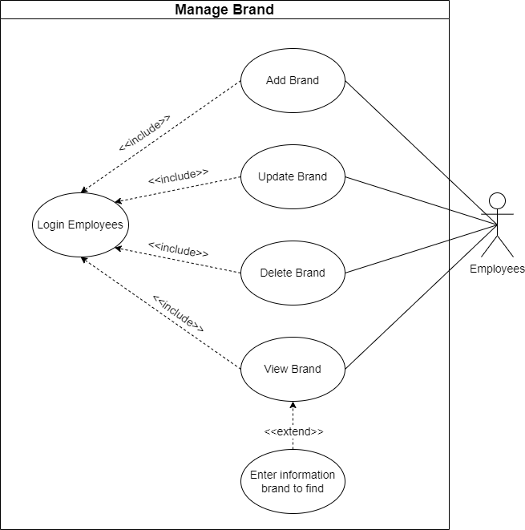

1. **Manage Supplier:** This module allows employee to information management of brand consisting of **adding new supplier information, updating supplier information, deleting supplier information and view supplier information.**

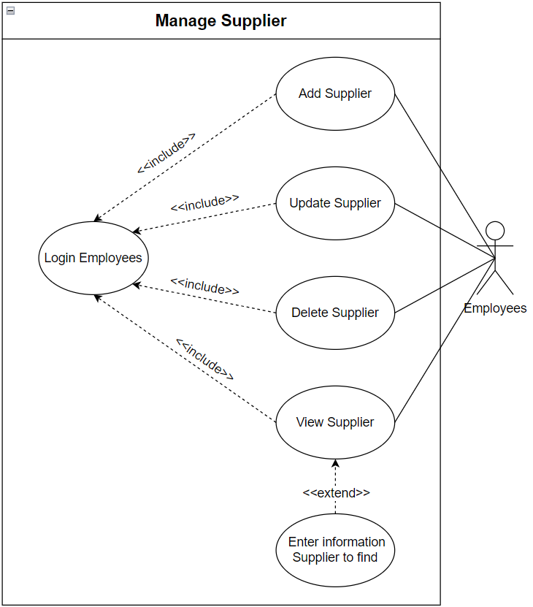

* 1. **Add Supplier**
* **Purpose:** This module allows employee can add new supplier information.
* **Input:**

+ ID of supplier

+ Company name of supplier

+ Contact name of supplier

+ Contact title of supplier

+ Contact name of supplier

+ Address of supplier

+ Phone of supplier

+ Fax of supplier

+ Postal code of supplier

+ Home page of supplier

+ Description of supplier

* **Output:** New information of supplier is added to table brand in the database.
  1. **Update Supplier**
* **Purpose:** This module allows employee can update supplier information.
* **Input:**

+ ID of supplier

* + Company name of supplier
* + Contact name of supplier
* + Contact title of supplier
* + Contact name of supplier
* + Address of supplier
* + Phone of supplier
* + Fax of supplier
* + Postal code of supplier
* + Home page of supplier
* + Description of supplier
* **Output:** Information of supplier is updated in the table brand in the database.
  1. **Delete Supplier**
* **Purpose:** This module allows employee can delete supplier information.
* **Input:** Empty.
* **Output:** Supplier information is deleted in the table supplier in the database.
  1. **Delete Supplier**
* **Purpose:** This module allows employee can supplier brand information.
* **Input:** Empty.
* **Output:** Supplier information is deleted in the table brand in the database.
  1. **View Supplier**
* **Purpose:** This module allows employee can view supplier information and search information of supplier.
* **Input:**

+ Name of supplier

* **Output:** The system will display list of supplier information or display searchable information of supplier when employee find brand information.

1. **Hardware and Software required for implementing the project**

|  |  |  |
| --- | --- | --- |
|  | **Server** | **Client** |
| **Hardware** | Processor:  Minimum2 GHz(processor x86) or 1.4 GHz (processor x64).  Recommendations: processing speed from 2GHz or more.  Ram: from 8GB or more.  Rom: from 50GB or more. | PC  Laptop  Smartphone. |
| **Software** | Glassfish 4.1.2  Tomcat 9  SQL Server 2016  Operating systems from Windows 10 or more, MAC OS X Server, .... | Popular web browsers like chrome, edge, ….  Operating systems from Windows 10 or more, Android 5.0 or more,… |
| **Additional Technology** | Bootstrap  Bootstrap table  CKeditor  Jquery | Bootstrap  Jquery |

# CUSTOMER ACCEPTANCE CRITERIA

|  |  |
| --- | --- |
| **No.** | **Customer’s Acceptance Criteria** |
| 1 | There is a division of user roles in the login function (Customer, Admin). |
| 2 | Guest role users cannot shop. |
| 3 | Users can log in with their name and password and can retrieve their password if they forget it. |
| 4 | Information when users register for an account must include: full name, username, password, email address, contact number. |
| 5 | Can search products based on Category, Price, Brand and show the searcher all related products. |
| 6 | View images and features of the selected product including price,... |
| 7 | Calculate the total amount of the product to create an invoice and pay the user. |
| 8 | Review user's order history. |
| 9 | Rate products and write user reviews. |
| 10 | Product categories can be added, updated, or deleted. |
| 11 | Product can be added, updated, or deleted. |
| 12 | Brand can be added, updated, or deleted. |
| 13 | Create reports on revenue by day, month, year / Revenue by brand / Revenue by category. |
| 14 | There is a categorized menu. |
| 15 | Attractive home page with incentives. |
| 16 | Products must be paged properly. |
| 17 | There is an about us page with the supermarket's address and contact details. |

# Project Plan

1. **Project Details**
2. **Name of the Client:** Zip Mart-Commerce Company
3. **Date of the Project Plan:** 11/07/2023
4. **Project Vision/Objectives:**

* User Management: Streamlining the process of managing user members.
* Services Management: Efficiently handling the services like feedback, blog.
* Product Management: Organizing and overseeing the supermarket product inventory.

1. **Scope:**

* The scope of operation of the online supermarket system can cover nationwide.
* The service scope of the online supermarket system: Currently, the system has separate departments responsible for different functions. The diverse product categories include electronics, fashion, household items, etc:

+ Customer management, employee management.

+ Product management, category management, order management.

+ Branch management, supplier management, brand management.

* Selling (product search, product display, shopping cart, add products to the cart, apply discount codes, payment, product reviews).

1. **Our understanding of the client organization:**

* Customers can view and search for products, then add them to the shopping cart and proceed to checkout. After payment, the system will generate and send the order information to the customer. The final step is for the system to send the order information to the administrator.
* Upon receiving the order, the administrator will confirm the order and assign it to the department responsible for preparing and packaging the products. The order will then be handed over to the shipping department for delivery to the customer.
* The administrator has the authority to add new products, update product information, or remove products that are no longer available for sale. They can search for products in the database and manage the stock quantity of each product in the inventory. The administrator can generate daily, monthly, and yearly revenue reports. Additionally, they can create discount codes, update information on discount codes, or delete expired discount codes. The administrator also has the ability to approve the status of orders and manage system users.

1. **Project Organization with Responsibilities and Authorities:**

|  |  |  |  |
| --- | --- | --- | --- |
| **No** | **Member** | **Roles** | **Responsibilities** |
| **1** | To Quang Tuong | Leader | Implementation,  Deployment,  Testing,  Maintenance and Support. |
| **2** | Pham Hieu Tho | Member | Requirements,  Design,  Implementation,  Testing. |
| **3** | Pham Huu Nhan | Member | Implementation,  Testing,  Maintenance and Support. |

1. **Project Initiation/Requirement Documents**

* India specification
* Winmart: (<https://winmart.vn/>)
* BigC: (https://www.bigc.vn/)
* Go: (<https://go-vietnam.vn/>)

1. **Deliverables**

* Document
* Source web application
* Client Requirement Specification (CRS): Document outlining the client's specific requirements.
* Design Document: Detailed documentation of the system's architecture and design.
* Installation instructions: Instructions on how to install and setup the supermarket system.
* A code documentation: Documentation of the source code and system structure.

1. **Project Dependencies**

Some events affect the success of the project like:

* Slow process.
* Devices and software have problems.

1. **Major Project Milestones**

|  |  |  |  |  |  |  |  |  |  |  |  |  |  |  |  |  |  |  |  |  |  |  |  |  |  |
| --- | --- | --- | --- | --- | --- | --- | --- | --- | --- | --- | --- | --- | --- | --- | --- | --- | --- | --- | --- | --- | --- | --- | --- | --- | --- |
| **Task Name** | **Week 1** | | | | | **Week 2** | | | | | **Week 3** | | | | | **Week 4** | | | | | **Week 5** | | | | |
| **M** | **T** | **W** | **T** | **F** | **M** | **T** | **W** | **T** | **F** | **M** | **T** | **W** | **T** | **F** | **M** | **T** | **W** | **T** | **F** | **M** | **T** | **W** | **T** | **F** |
| **Requirements** |  |  |  |  |  |  |  |  |  |  |  |  |  |  |  |  |  |  |  |  |  |  |  |  |  |
| **Design** |  |  |  |  |  |  |  |  |  |  |  |  |  |  |  |  |  |  |  |  |  |  |  |  |  |
| **Implementation** |  |  |  |  |  |  |  |  |  |  |  |  |  |  |  |  |  |  |  |  |  |  |  |  |  |
| **Deployment** |  |  |  |  |  |  |  |  |  |  |  |  |  |  |  |  |  |  |  |  |  |  |  |  |  |
| **Testing** |  |  |  |  |  |  |  |  |  |  |  |  |  |  |  |  |  |  |  |  |  |  |  |  |  |

1. **Quality Plan**
2. **Review Activities:**

* Review meeting participants: To Quang Tuong, Pham Hieu Tho, Pham Huu Nhan
* Frequency: 4 times per week.
* Meeting content: Deploy and try to focus and quickly complete assigned tasks each week

1. **Testing Activities:**

* Testing with 4 times per week.
* Final Test: 5 times.

1. **Backup and Recovery Strategies:**

* Regular automated backups of the system and data to prevent data loss in case of disk crashes or network failures.
* Implementation of redundancy and failover systems to minimize downtime and ensure continuous service availability in case of system failures.
* Backup on github: <https://github.com/Raiklip/ZipmartSupermarket.git>

# GUI STANDARD OF APPLICATION

1. **Architecture of Application**

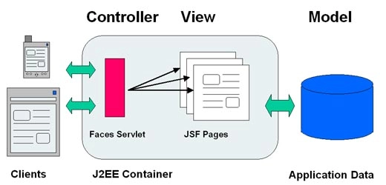

1. **GUI Standard Application**

|  |  |
| --- | --- |
| **Property** | **Value** |
| Document Theme and Color Scheme | Zip Mart |
| Form - Background Color | White, Blue |
| Title - Font Size | 14 |
| Title - Font Color | Black |
| Title - Font Style | Time New Roman |
| Title - Alignment | Center |
| Background color of Controls on the form | Blue, Black, White |
| Foreground color of Controls on the form | Black |
| Control Caption - Font Size | 13 |
| Control Caption - Font Color | Black |
| Control Caption - Font Style | Time New Roman |
| Control caption and controls - Alignment | Center |
| Command button - Alignment | Center |

# INTERFACE DESIGN DOCUMENT

1. **Main Interface**
2. **MAIN MENU**

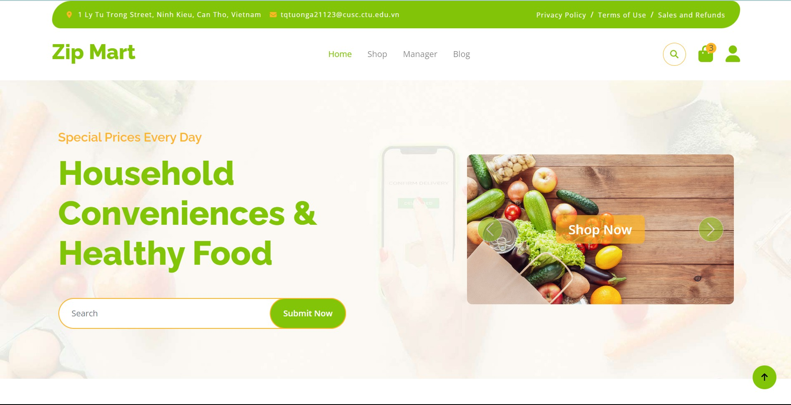

*Figure 1. The home page includes many functions for customers.*

1. **SHOP**

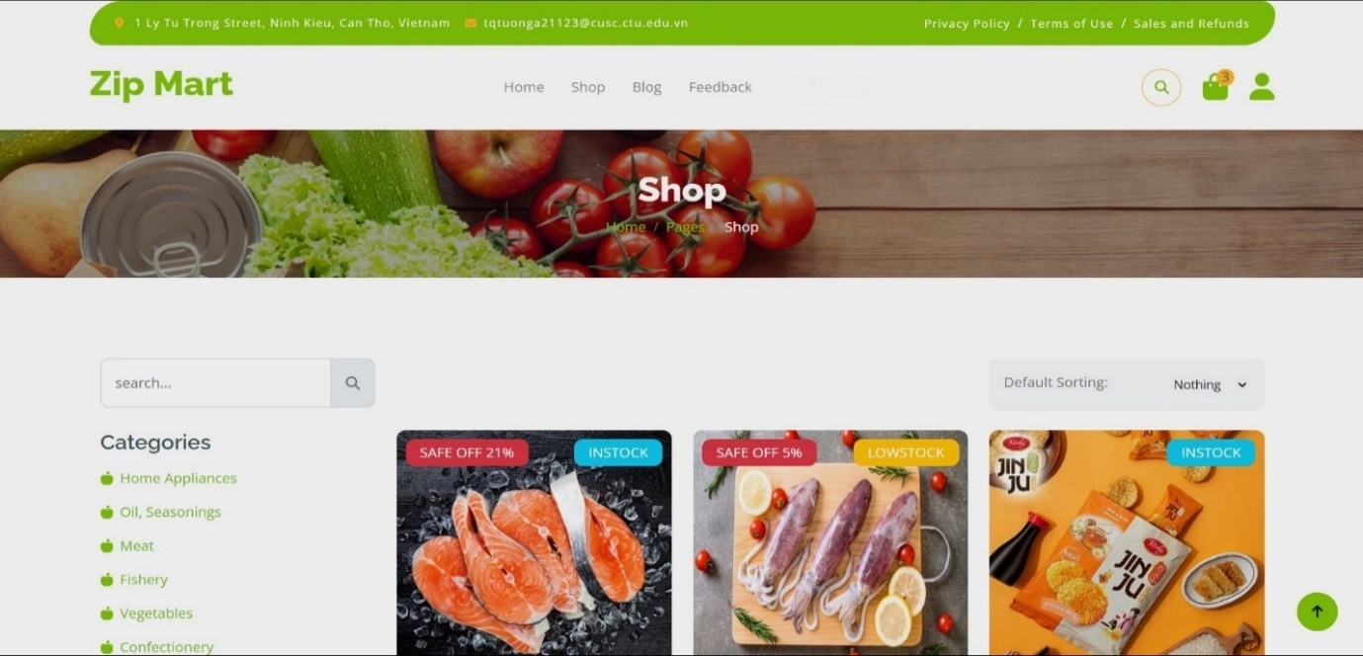 *Figure 2(a). Displays all of the website's products, allowing users to view and purchase products.*

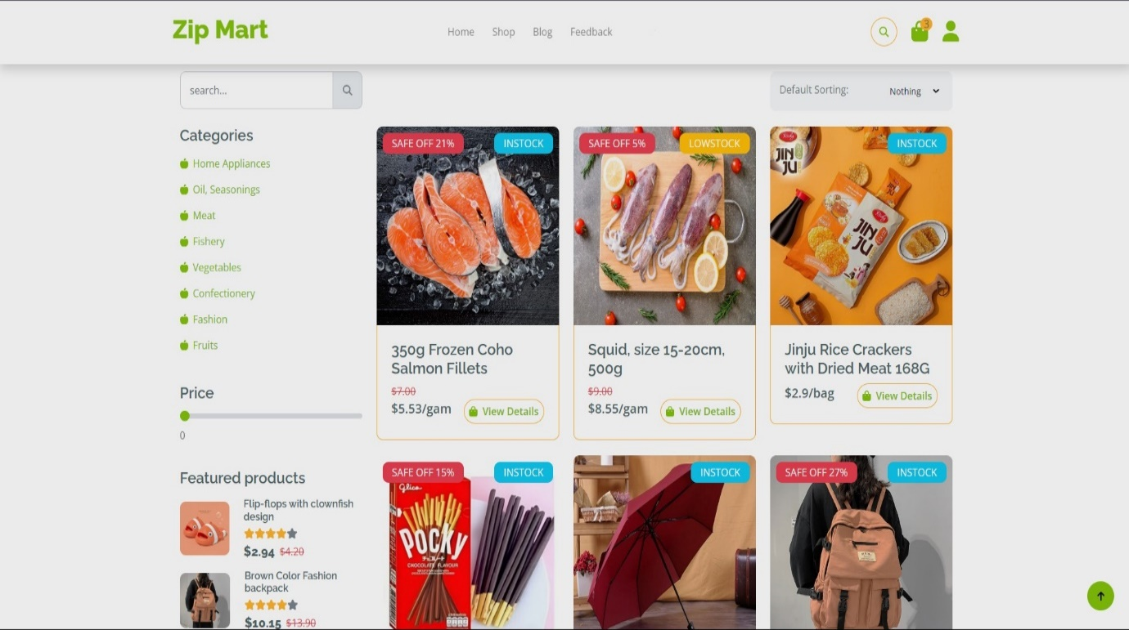 *Figure 2(b).* *Display products on sale, items with the best prices.*

1. **BLOG**

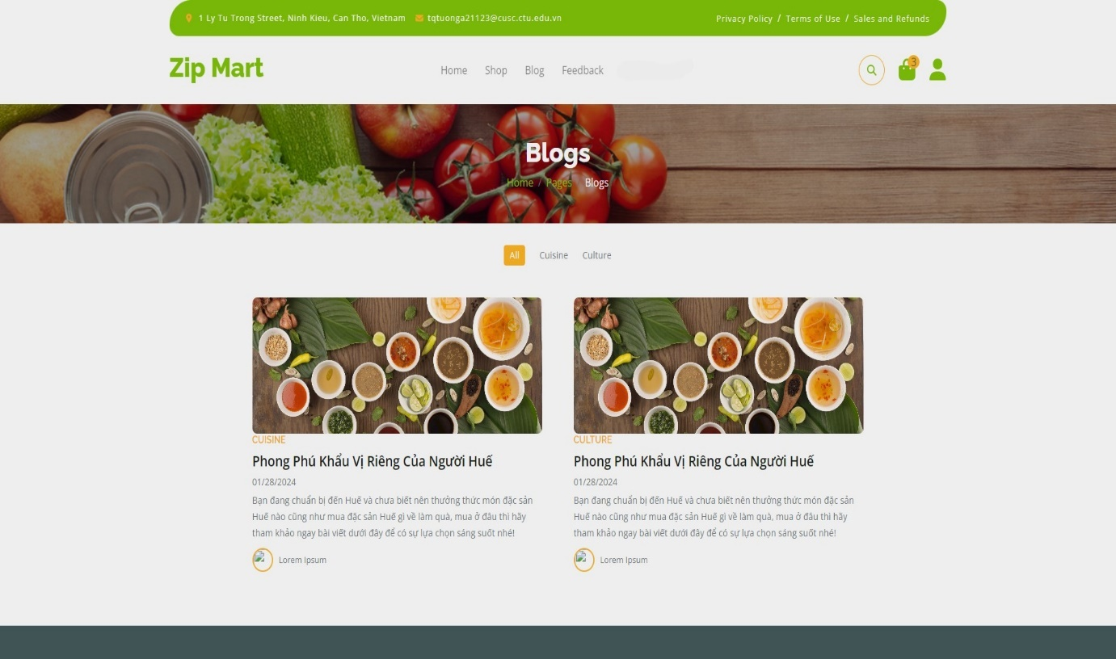 *Figure 3. Blog*

1. **PRODUCT DETAILS**

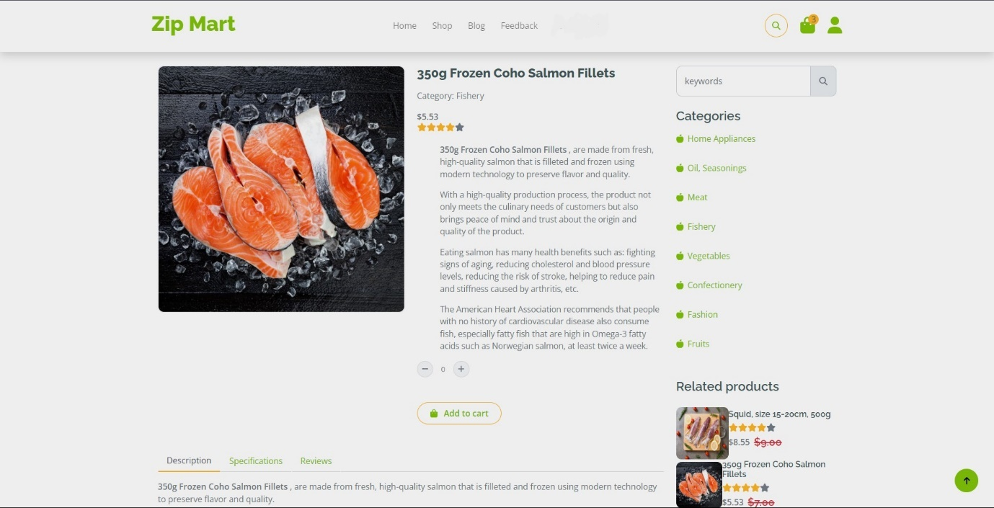

*Figure 4. Display product details, allowing users to order.*

1. **CART**

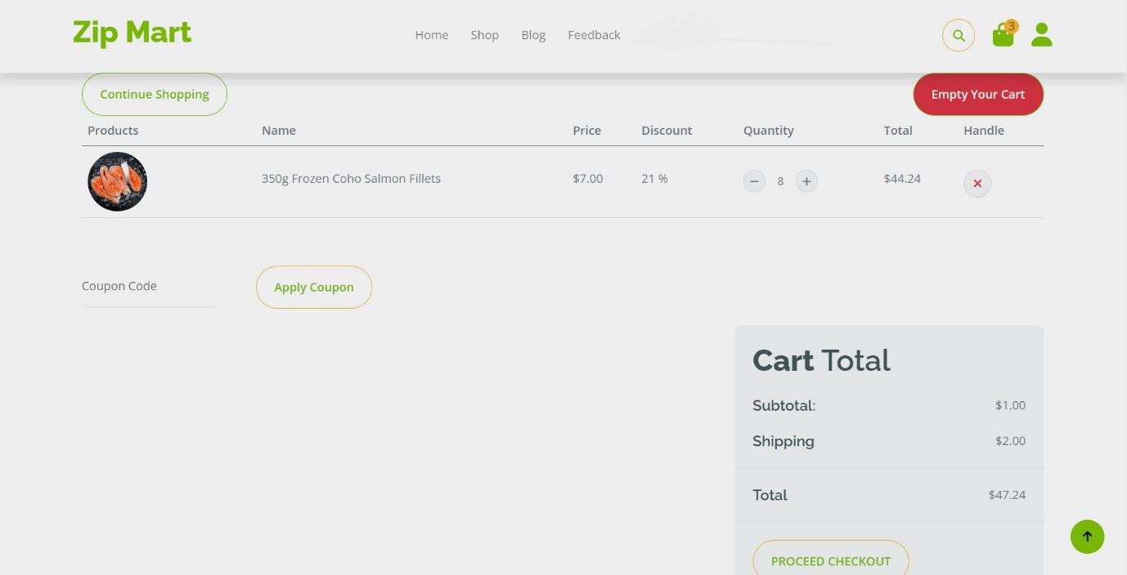

*Figure 5. Display product details, allowing users to order and pay for products.*

1. **CONTACT US**

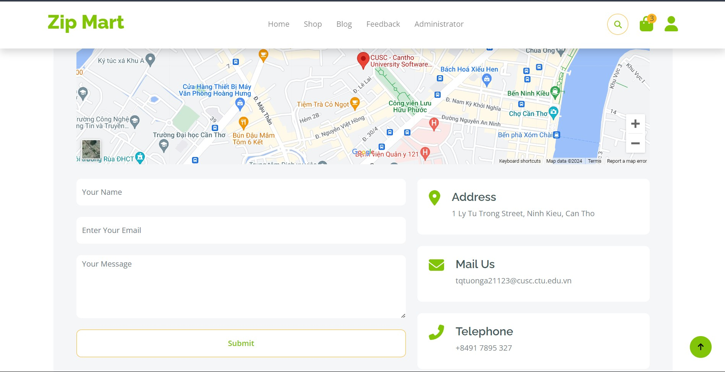

*Figure 6. Displays the store location on the map, and how to contact the store manager.*

1. **Admin Page**
2. **DASHBOARD**

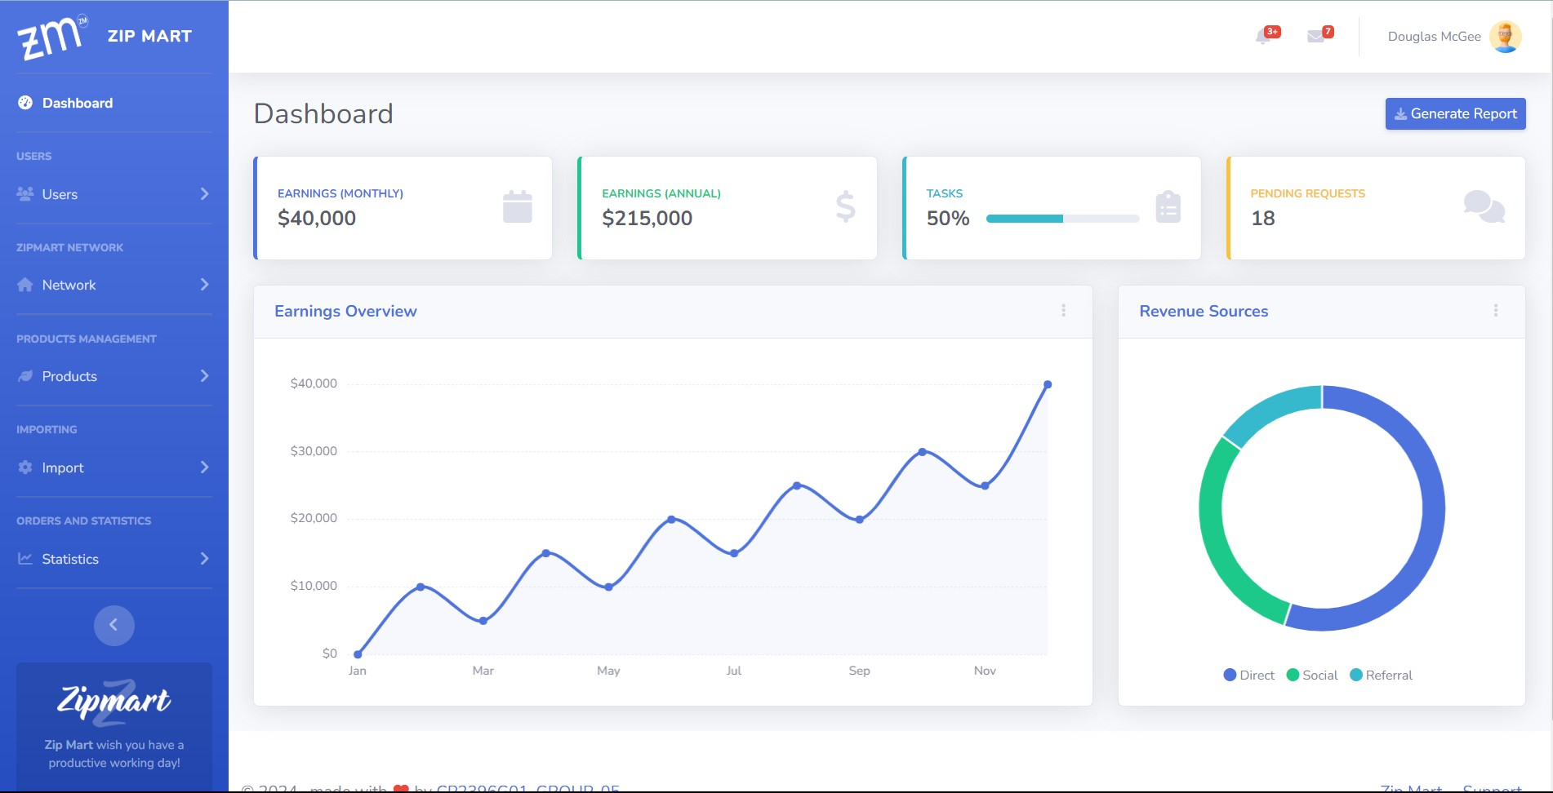

*Figure 7. Index Admin page.*

1. **USER**

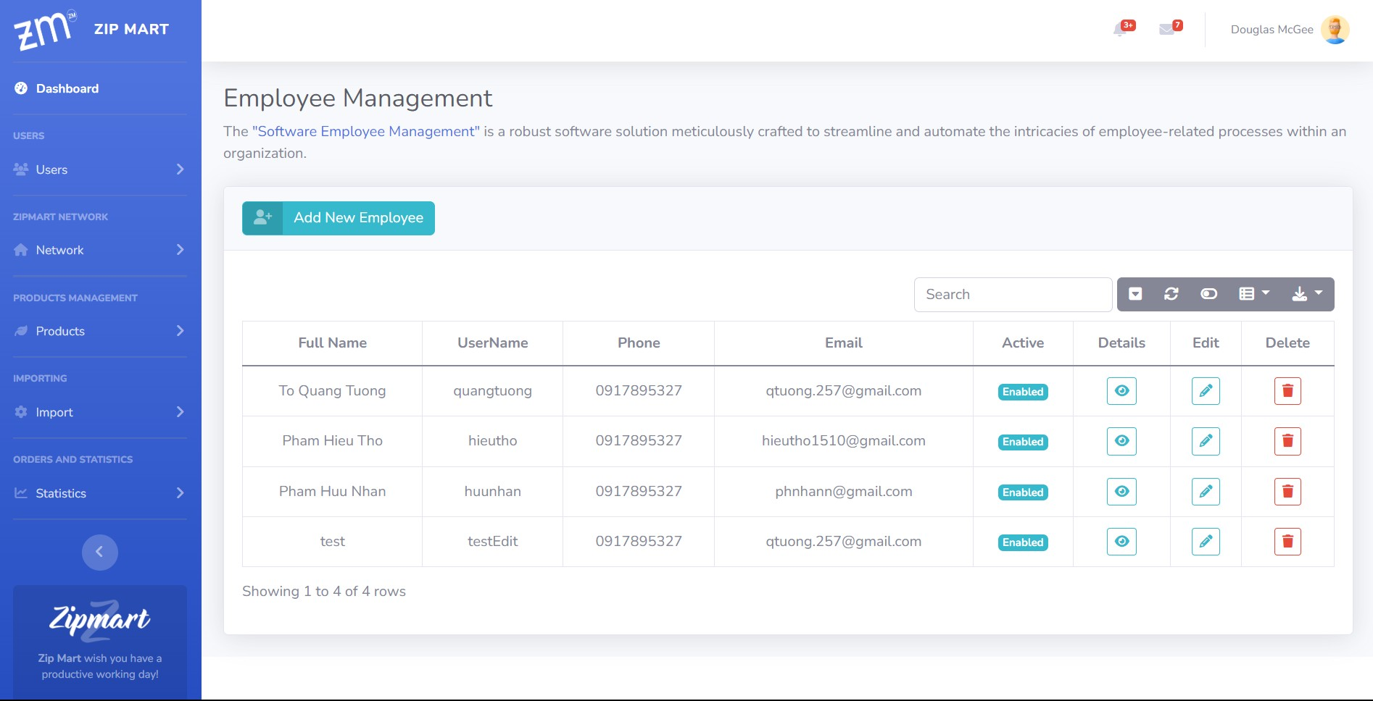

*Figure 8. This page will display the "Employee" table including the function of adding, editing, and deleting, search , detail employee.*

1. **ADD NEW PRODUCT**

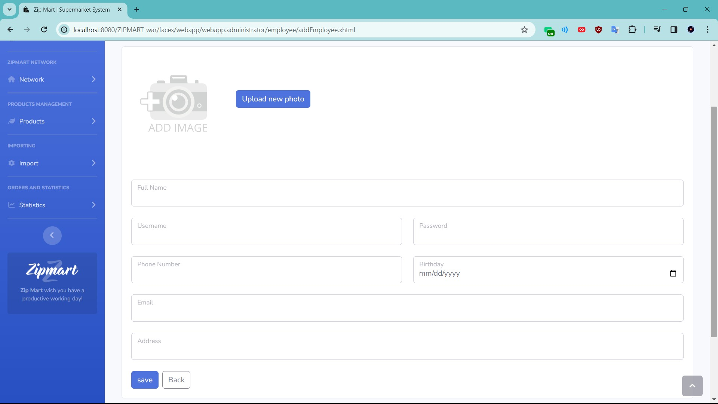

*Figure 9. You can add photos and detailed information of new products.*

# DATABASE DESIGN DOCUMENT

1. **ER/ Class Diagram**

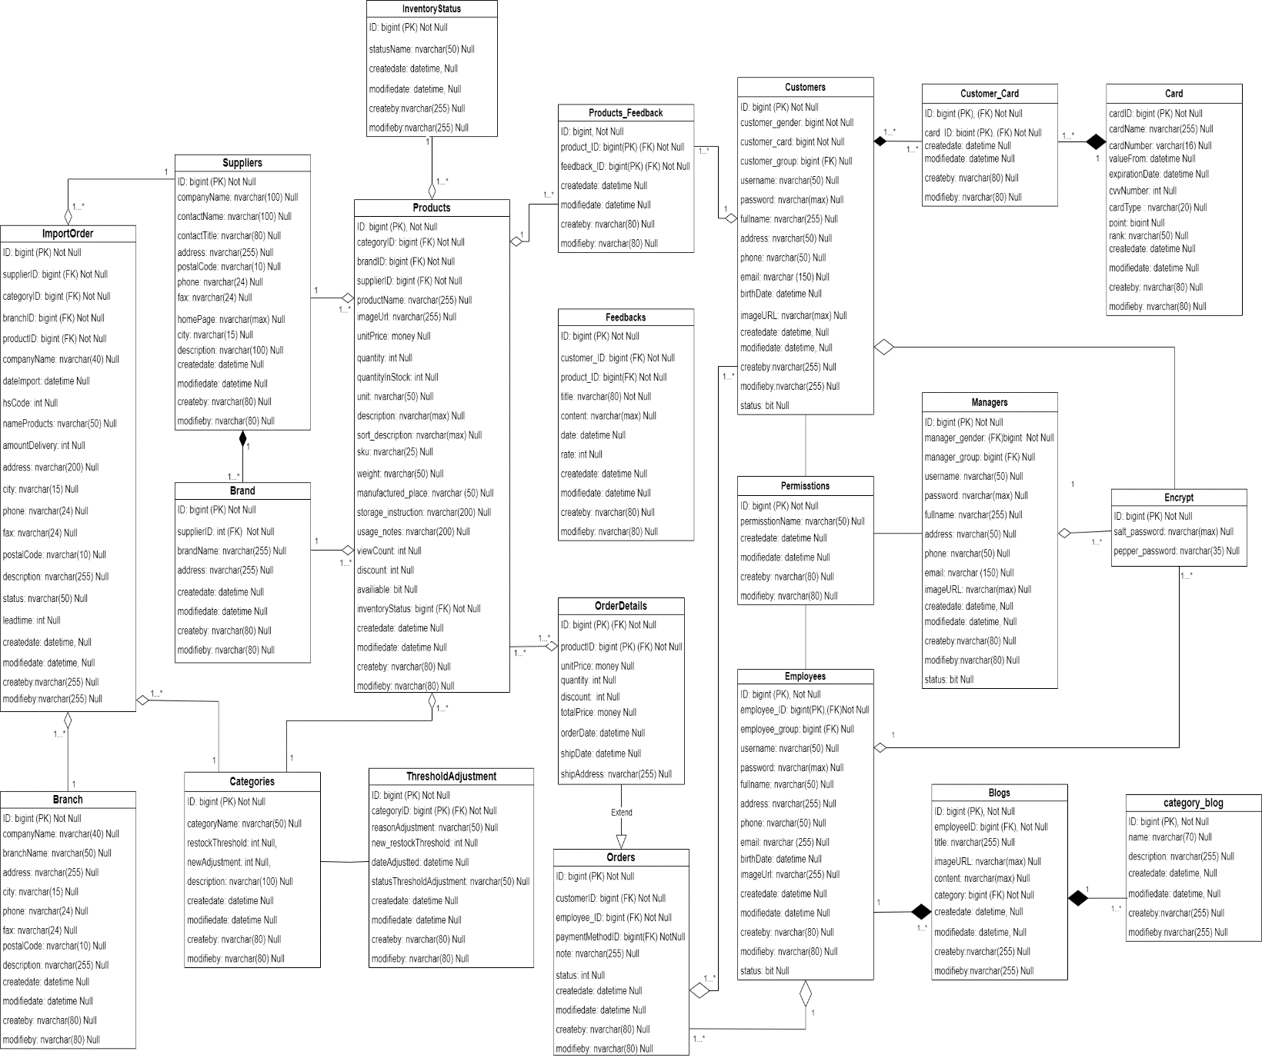

1. **Table Description**

|  |  |  |  |
| --- | --- | --- | --- |
| **Blogs** | | | |
| **Field Name** | **Data Type** | **Constraint  (Primary Key, Foreign Key, Identity, Not Null,...)** | **Description** |
| ID | bigint | Primary Key, Not Null | ID of blog |
| employee_ID | bigint | Null | ID of employee |
| title | nvarchar (255) | Null | Title of blog |
| imageURL | nvarchar (255) | Null | Image of blog |
| category | nvarchar (255) | Null | Category of blog |
| sortcontent | nvarchar (max) | Null | Sort content of blog |
| content | nvarchar (max) | Null | Content of blog |
| createdate | datetime | Null | Day of create blog |
| modifiedate | datetime | Null | Day of modify blog |
| createby | nvarchar (50) | Null | Name user create blog |
| modifieby | nvarchar (50) | Null | User name modifie blog |

|  |  |  |  |
| --- | --- | --- | --- |
| **Blog_Categories** | | | |
| **Field Name** | **Data Type** | **Constraint  (Primary Key, Foreign Key, Identity, Not Null,...)** | **Description** |
| ID | bigint | Primary Key, Not Null | ID of blog_category |
| name | nvarchar (50) | Null | Name of blog_category |
| description | nvarchar (50) | Null | Description of blog_category |
| createdate | datetime | Null | Day of create blog_category |
| modifiedate | datetime | Null | Day of modify blog_category |
| createby | nvarchar (255) | Null | Name user create blog_category |
| modifieby | nvarchar (255) | Null | User name modify blog_category |

|  |  |  |  |
| --- | --- | --- | --- |
| **Branch** | | | |
| **Field Name** | **Data Type** | **Constraint  (Primary Key, Foreign Key, Identity, Not Null,...)** | **Description** |
| ID | bigint | Primary Key, Not Null | ID of brand |
| companyName | nvarchar (40) | Null | Name of company |
| branchName | nvarchar (50) | Null | Name of branch |
| city | nvarchar (15) | Null | Name of city |
| address | nvarchar (255) | Null | Address of branch |
| phone | nvarchar (24) | Null | Phone of branch |
| fax | nvarchar (24) | Null | Fax of branch |
| postalCode | nvarchar (10) | Null | Postal Code of branch |
| description | nvarchar (255) | Null | Description of branch |
| createdate | datetime | Null | Day of create branch |
| modifiedate | datetime | Null | Day of modify branch |
| createby | nvarchar (255) | Null | Name user create branch |
| modifieby | nvarchar (255) | Null | Name user modify branch |

|  |  |  |  |
| --- | --- | --- | --- |
| **Brand** | | | |
| **Field Name** | **Data Type** | **Constraint  (Primary Key, Foreign Key, Identity, Not Null,...)** | **Description** |
| ID | bigint | Primary Key, Not Null | ID of brand |
| supplierID | bigint | Foreign Key, Not Null | ID of supplier |
| brandName | nvarchar (50) | Null | Name of brand |
| address | nvarchar (255) | Null | Address of brand |
| createdate | datetime | Null | Day of create brand |
| modifiedate | datetime | Null | Day of modify brand |
| createby | nvarchar (255) | Null | Name user create brand |
| modifieby | nvarchar (255) | Null | name user modify brand |

|  |  |  |  |
| --- | --- | --- | --- |
| **Cards** | | | |
| **Field Name** | **Data Type** | **Constraint  (Primary Key, Foreign Key, Identity, Not Null,...)** | **Description** |
| ID | bigint | Primary Key, Not Null | ID of card |
| cardName | nvarchar (255) | Null | Name of card |
| cardNumber | int | Null | Number of card |
| valueFrom | datetime | Null | Value form of card |
| expirationDate | datetime | Null | Day of expiration |
| cvvNumber | int | Null | Number of cvv |
| cardType | nvarchar (20) | Null | Type of card |
| point | bigint | Null | Point of card |
| rank | nvarchar (50) | Null | Rank of card |
| createdate | datetime | Null | Day of create card |
| modifiedate | datetime | Null | Day of modify card |
| createby | datetime | Null | Name user create card |
| modifieby | nvarchar (50) | Null | Name user modify card |

|  |  |  |  |
| --- | --- | --- | --- |
| **Categories** | | | |
| **Field Name** | **Data Type** | **Constraint  (Primary Key, Foreign Key, Identity, Not Null,…)** | **Description** |
| ID | int | Primary Key, Not Null | ID of category |
| categoryName | nvarchar (50) | Null | Name of category |
| restockThreshold | int | Null | Restock Threshold of category |
| newAdjustment | int | Null | New adjustment of category |
| description | nvarchar (255) | Null | Description of category |

|  |  |  |  |
| --- | --- | --- | --- |
| **Customers** | | | |
| **Field Name** | **Data Type** | **Constraint  (Primary Key, Foreign Key, Identity, Not Null,...)** | **Description** |
| ID | bigint | Primary Key, Not Null | ID of customer |
| customer_card | bigint | Null | Card of customer |
| customer_group | bigint | Foreign Key, Null | Group of customer |
| username | nvarchar (50) | Null | Username of customer |
| password | nvarchar(max) | Null | Password of customer |
| fullname | nvarchar (255) | Null | Full name of customer |
| address | nvarchar (255) | Null | Address of customer |
| phone | nvarchar (50) | Null | Phone of customer |
| email | nvarchar (255) | Null | Email of customer |
| birthDate | datetime | Null | Birthday of customer |
| imageURL | nvarchar(max) | Null | Image of customer |
| status | datetime | Null | Status of account customer |
| modifiedate | datetime | Null | Day of modify customer |
| createby | nvarchar (255) | Null | Name user of create customer |
| modifieby | nvarchar (50) | Null | Name user modify customer |
| status | bit | Null | ID of customer |

|  |  |  |  |
| --- | --- | --- | --- |
| **Feedbacks** | | | |
| **Field Name** | **Data Type** | **Constraint  (Primary Key, Foreign Key, Identity, Not Null,…)** | **Description** |
| ID | bigint | Primary Key, Not Null | ID of feedback |
| title | nvarchar (255) | Not Null | Title of feedback |
| content | nvarchar(max) | Null | Content of feedback |
| date | datetime | Null | Day of feedback |
| rate | int | Null | Rate of feedback |
| createdate | datetime | Null | Day of create feedback |
| modifiedate | datetime | Null | Day of modify feedback |
| createby | nvarchar (50) | Null | Name user create feedback |
| modifieby | nvarchar (50) | Null | Name user modify feedback |

|  |  |  |  |
| --- | --- | --- | --- |
| **Customers_Card** | | | |
| **Field Name** | **Data Type** | **Constraint  (Primary Key, Foreign Key, Identity, Not Null,...)** | **Description** |
| customerID | bigint | Primary Key, Foreign Key, Not Null | ID of customer |
| cardID | bigint | Primary Key, Foreign Key, Not Null | ID of card |
| createdate | datetime | Null | Day of create customer_card |
| modifiedate | datetime | Null | Day of modify customer_card |
| createby | nvarchar (255) | Null | Name user create customer card |
| modifieby | nvarchar (50) | Null | Name user modify customer card |

|  |  |  |  |
| --- | --- | --- | --- |
| **Employees** | | | |
| **Field Name** | **Data Type** | **Constraint  (Primary Key, Foreign Key, Identity, Not Null,…)** | **Description** |
| ID | bigint | Primary Key, Not Null | ID of employee |
| employee_group | bigint | Foreign Key, Not Null | Group of employee |
| username | nvarchar (50) | Null | Username of employee |
| password | nvarchar(max) | Null | Password of employee |
| fullname | nvarchar (50) | Null | Full name of employee |
| address | nvarchar (255) | Null | Address of employee |
| phone | nvarchar (50) | Null | Phone of employee |
| email | nvarchar (255) | Null | Email of employee |
| birthDate | datetime | Null | Birhday of employee |
| imageURL | nvarchar (255) | Null | Image of employee |
| createdate | datetime | Null | Day of create employee |
| modifiedate | datetime | Null | Day of modify employee |
| createby | nvarchar (50) | Null | Name user create employee |
| modifieby | nvarchar (50) | Null | Name of modify employee |
| status | bit | Null | Status of employee |

|  |  |  |  |
| --- | --- | --- | --- |
| **Encrypt** | | | |
| **Field Name** | **Data Type** | **Constraint  (Primary Key, Foreign Key, Identity, Not Null,…)** | **Description** |
| ID | bigint | Primary Key, Not Null | ID of encrypt |
| salt | nvarchar (max) | Not Null | Salt of encrypt |
| pepper | nvarchar (35) | Null | Pepper of encrypt |

|  |  |  |  |
| --- | --- | --- | --- |
| **Feedbacks_Products** | | | |
| **Field Name** | **Data Type** | **Constraint  (Primary Key, Foreign Key, Identity, Not Null,…)** | **Description** |
| ID | bigint | Primary Key, Not Null | ID of feedback pro |
| customerID | bigint | Foreign Key, Not Null | ID of customer |
| productID | bigint | Foreign Key, Not Null | ID of product |
| title | nvarchar (255) | Not Null | Title of feedback pro |
| content | nvarchar (max) | Null | Content of feedback pro |
| date | datetime | Null | Day of feedback pro |
| rate | int | Null | Rate of feedback pro |
| createdate | datetime | Null | Day of create feedback pro |
| modifiedate | datetime | Null | Day of modify feedback pro |
| createby | nvarchar (50) | Null | Name user of create feedback pro |
| modifieby | nvarchar (50) | Null | Name user of modify feedback pro |

|  |  |  |  |  |
| --- | --- | --- | --- | --- |
| **InventoryStatus** | | | | |
| **Field Name** | **Data Type** | **Constraint  (Primary Key, Foreign Key, Identity, Not Null,...)** | **Description** |
| statusID | int | Identity (1,1), Primary Key, Not Null | ID of status |
| statusName | nvarchar (50) | Null | Name of status |

|  |  |  |  |
| --- | --- | --- | --- |
| **ImportOrder** | | | |
| **Field Name** | **Data Type** | **Constraint  (Primary Key, Foreign Key, Identity, Not Null,...)** | **Description** |
| ID | bigint | Primary Key, Not Null | ID of import order |
| productID | bigint | Foreign Key, Not Null | ID of product |
| branchID | bigint | Foreign Key, Not Null | ID of branch |
| dateImport | datetime | Null | Day of Import order |
| hsCode | int | Null | hsCode of import order |
| amountDelivery | int | Null | Amount delivery of import order |
| status | nvarchar (50) | Null | Status of import order |
| description | nvarchar (255) | Null | Description of import order |
| leadtime | int | Null | Leadtime of import order |
| createdate | datetime | Null | Day of create import order |
| modifiedate | datetime | Null | Day of modify import order |
| createby | nvarchar (255) | Null | Name user of create import order |
| modifieby | nvarchar (255) | Null | Name user of modify import order |

|  |  |  |  |
| --- | --- | --- | --- |
| **Manager** | | | |
| **Field Name** | **Data Type** | **Constraint  (Primary Key, Foreign Key, Identity, Not Null,...)** | **Description** |
| ID | bigint | Primary Key, Not Null | ID of manager |
| manager_group | bigint | Foreign Key, Not Null | Group of manager |
| username | nvarchar (50) | Null | Username of manager |
| password | nvarchar (max) | Null | Password of manager |
| fullname | nvarchar (50) | Null | Full name of manager |
| address | nvarchar (255) | Null | Address of manager |
| phone | nvarchar (50) | Null | Phone of manager |
| email | nvarchar (255) | Null | Email of manager |
| imageURL | nvarchar(max) | Null | Image of manager |
| createdate | datetime | Null | Day of create manager |
| modifiedate | datetime | Null | Day of modify manager |
| createby | nvarchar (255) | Null | Name user of create manager |
| modifieby | nvarchar (50) | Null | Name user of modify manager |
| status | bit | Null |  |

|  |  |  |  |
| --- | --- | --- | --- |
| **OrderDetails** | | | |
| **Field Name** | **Data Type** | **Constraint  (Primary Key, Foreign Key, Identity, Not Null,...)** | **Description** |
| orderID | bigint | Primary Key, Foreign Key, Not Null | ID of order |
| productID | bigint | Primary Key, Foreign Key, Not Null | ID of product |
| unitPrice | money | Null | Unit price of order |
| quantity | int | Null | Quanity of order |
| discount | int | Null | Discount of order |
| totalPrice | money | Null | Total price of order |
| orderDate | datetime | Null | Day of order |
| shipDate | datetime | Null | Day of ship |
| shipAddress | nvarchar (255) | Null | Address of ship |

|  |  |  |  |
| --- | --- | --- | --- |
| **Order** | | | |
| **Field Name** | **Data Type** | **Constraint  (Primary Key, Foreign Key, Identity, Not Null,...)** | **Description** |
| ID | bigint | Primary Key, Not Null | ID of order |
| customerID | bigint | Foreign Key, Not Null | ID of customer |
| employeeID | bigint | Foreign Key, Not Null | ID of employee |
| paymentMethod | nvarchar (255) | Null | Payment method of order |
| notes | nvarchar (max) | Null | Note of order |
| status | nvarchar (50) | Null | Status of order |

|  |  |  |  |
| --- | --- | --- | --- |
| **Products** | | | |
| **Field Name** | **Data Type** | **Constraint  (Primary Key, Foreign Key, Identity, Not Null,...)** | **Description** |
| ID | bigint | Primary Key, Not Null | ID of product |
| categoryID | bigint | Foreign Key, Not Null | ID of category |
| brandID | bigint | Foreign Key, Not Null | ID of brand |
| supplierID | bigint | Foreign Key, Not Null | ID of suplier |
| productName | nvarchar (255) | Null | Name of product |
| imageURL | nvarchar (max) | Null | Image of product |
| unitPrice | money | Null | Unit price of product |
| quantity | int | Null | Quanity of product |
| quantityStock | int | Null | Quanity Stock of product |
| unit | nvarchar (50) | Null | Unit of product |
| description | nvarchar (255) | Null | Description of product |
| sortdescription | nvarchar(max) | Null | Sort description of product |
| manufactured_place | nvarchar (255) | Null | Manufacetured of product |
| sku | nvarchar (25) | Null | sku of product |
| storage_instruction | nvarchar (100) | Foreign Key, Not Null | Storage of product |
| usage_notes | nvarchar (100) | Null | Usage note of product |
| discount | int | Null | Discount of product |
| avaliable | bit | Null | Avaliable of product |
| inventoryStatus | bigint | Foreign Key, Not Null | Inventory Status of product |
| weight | nvarchar (50) | Null | Weight of product |
| createdate | datetime | Null | Day of create product |
| modifiedate | datetime | Null | Day of modify product |
| createby | nvarchar (255) | Null | Name user of create product |
| modifieby | nvarchar (255) | Null | Name user of modify product |

|  |  |  |  |
| --- | --- | --- | --- |
| **Suppliers** | | | |
| **Field Name** | **Data Type** | **Constraint  (Primary Key, Foreign Key, Identity, Not Null,...)** | **Description** |
| ID | bigint | Primary Key, Not Null | ID of supplier |
| companyName | nvarchar (255) | Null | Name of company |
| contactName | nvarchar (255) | Null | Name of contact |
| contactTitle | nvarchar (255) | Null | Title of contact |
| address | nvarchar (255) | Null | Address of supplier |
| city | nvarchar (15) | Null | City of supplier |
| phone | nvarchar (24) | Null | Phone of supplier |
| fax | nvarchar (24) | Null | Fax of supplier |
| postalCode | nvarchar (10) | Null | Postal Code of supplier |
| homePage | nvarchar(max) | Null | Home page of supplier |
| createdate | datetime | Null | Day of create supplier |
| modifiedate | datetime | Null | Day of modify supplier |
| createby | nvarchar (255) | Null | Name user of create supplier |
| modifieby | nvarchar (255) | Null | Name user of modify supplier |

|  |  |  |  |
| --- | --- | --- | --- |
| **ThresholdAdjustment** | | | |
| **Field Name** | **Data Type** | **Constraint  (Primary Key, Foreign Key, Identity, Not Null,…)** | **Description** |
| ID | bigint | Primary Key, Not Null | ID of thersholdAdjustment |
| categogyID | bigint | Foreign Key, Not Null | ID of category |
| reasonAdjustment | nvarchar (50) | Null | Reason Adjustment of thersholdAdjustment |
| new_restockThreshold | int | Null | New restock of thersholdAdjustment |
| dateAdjusted | datetime | Null | Day of Adjusted |
| statusThresholdAdjustments | nvarchar (50) | Null | Status of thersholdAdjustment |

# PROCESS DESIGN DOCUMENT

1. **Employee**
   1. **Create Employee**

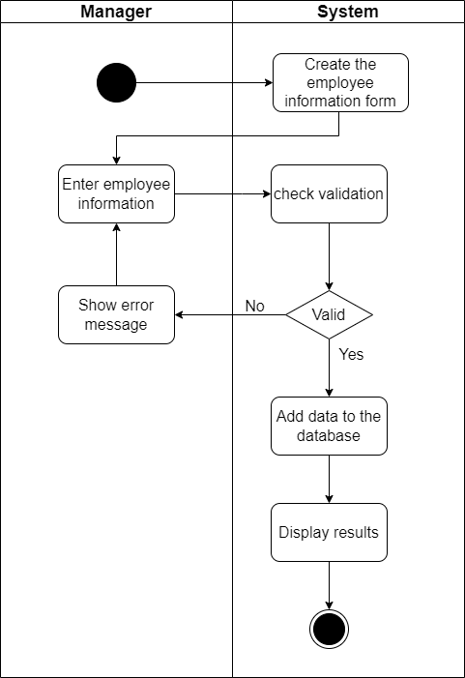

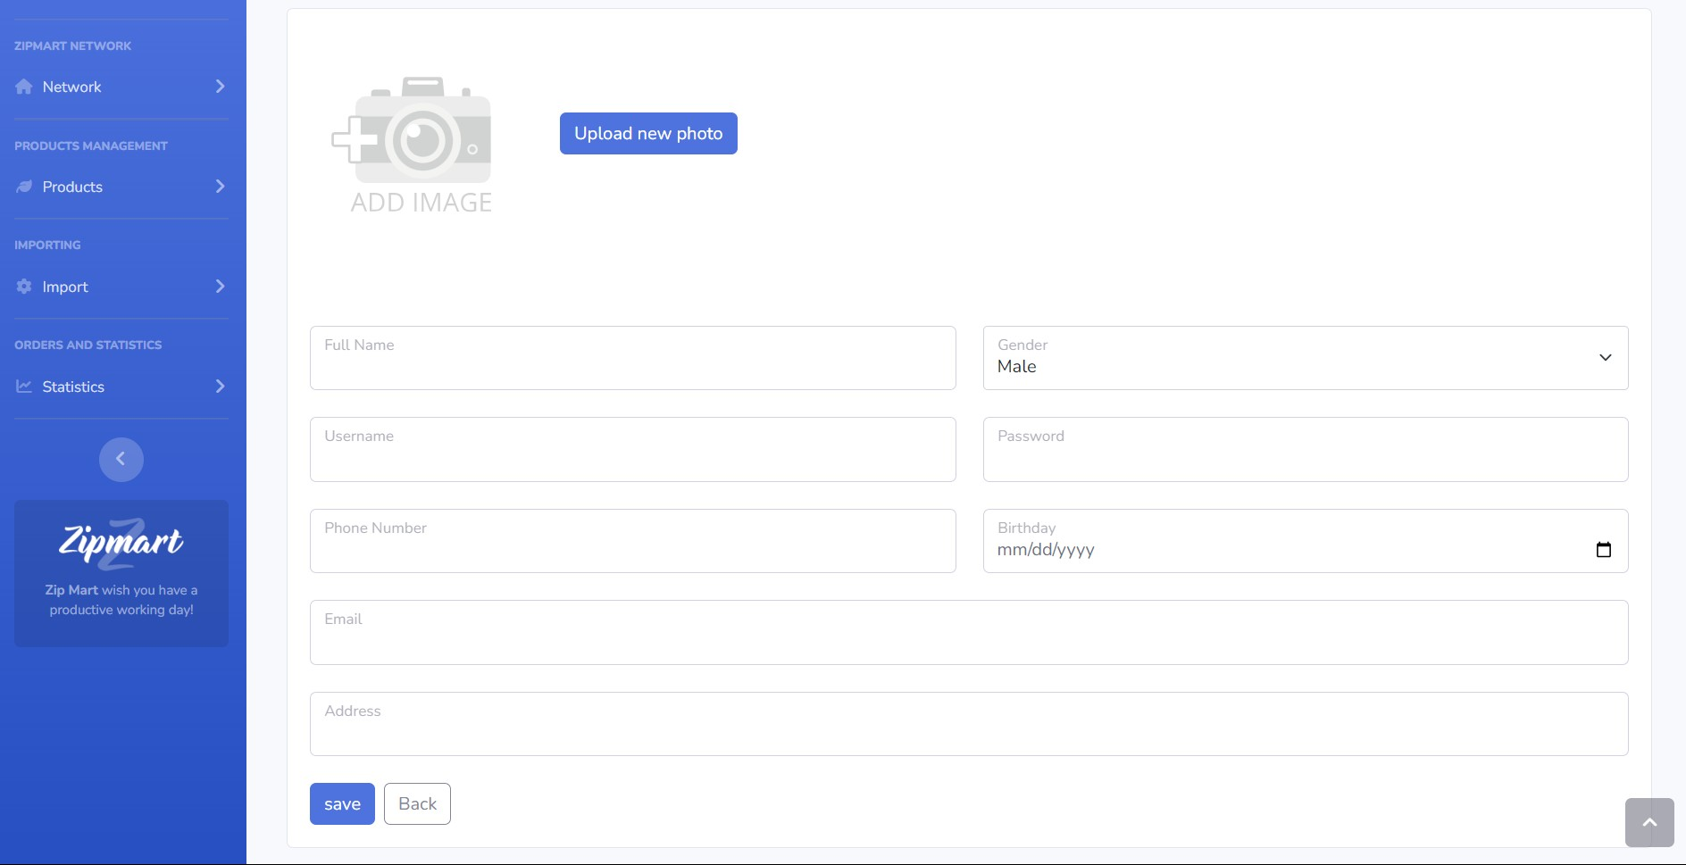

* 1. **Update Employee**

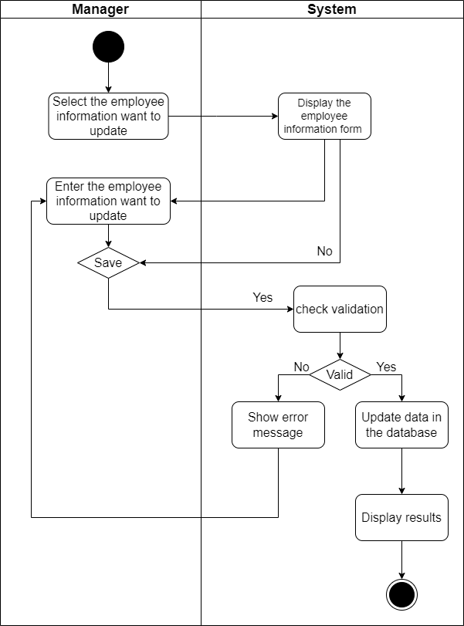

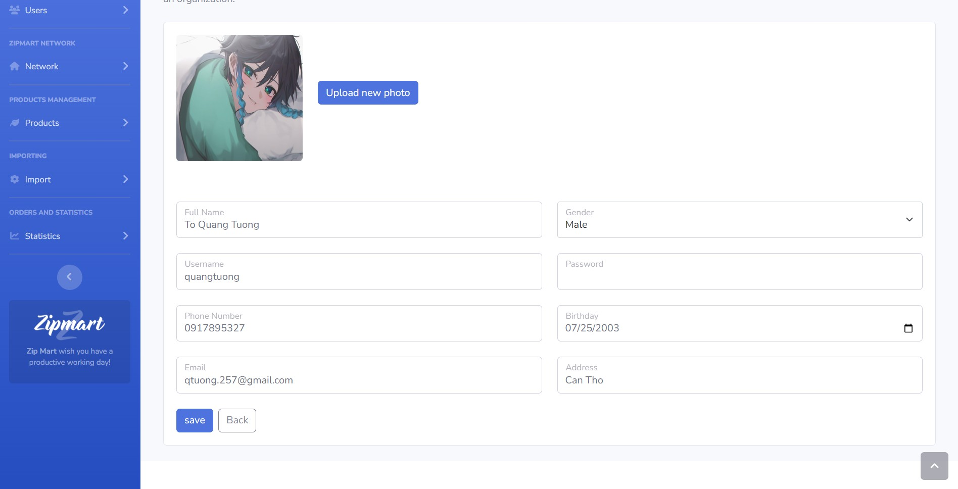

* 1. **Delete Employee**

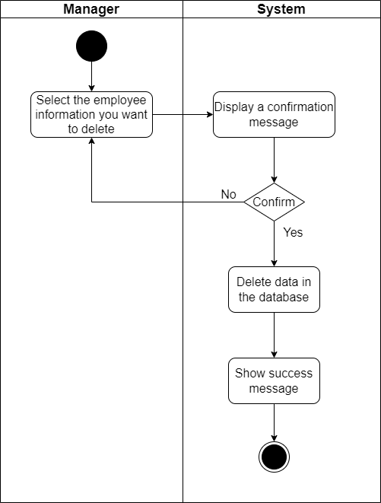

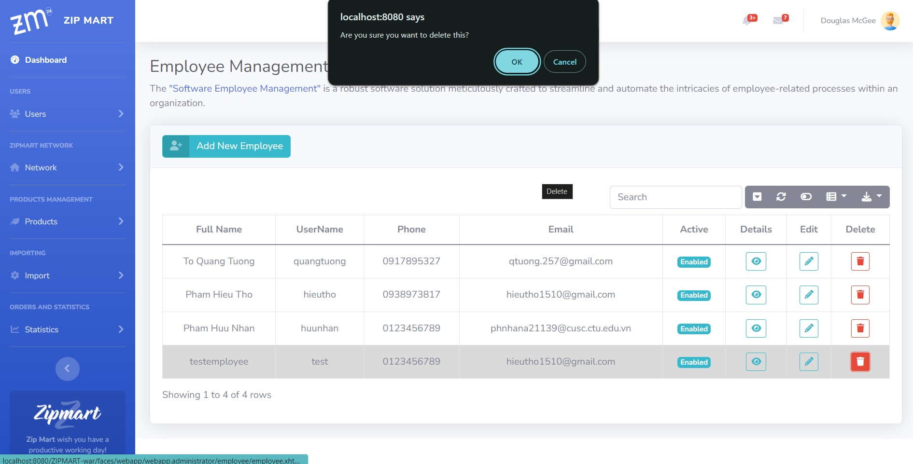

* 1. **Find Employee**

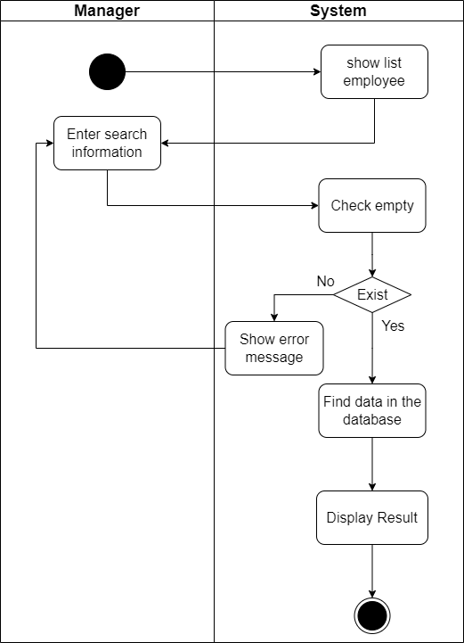

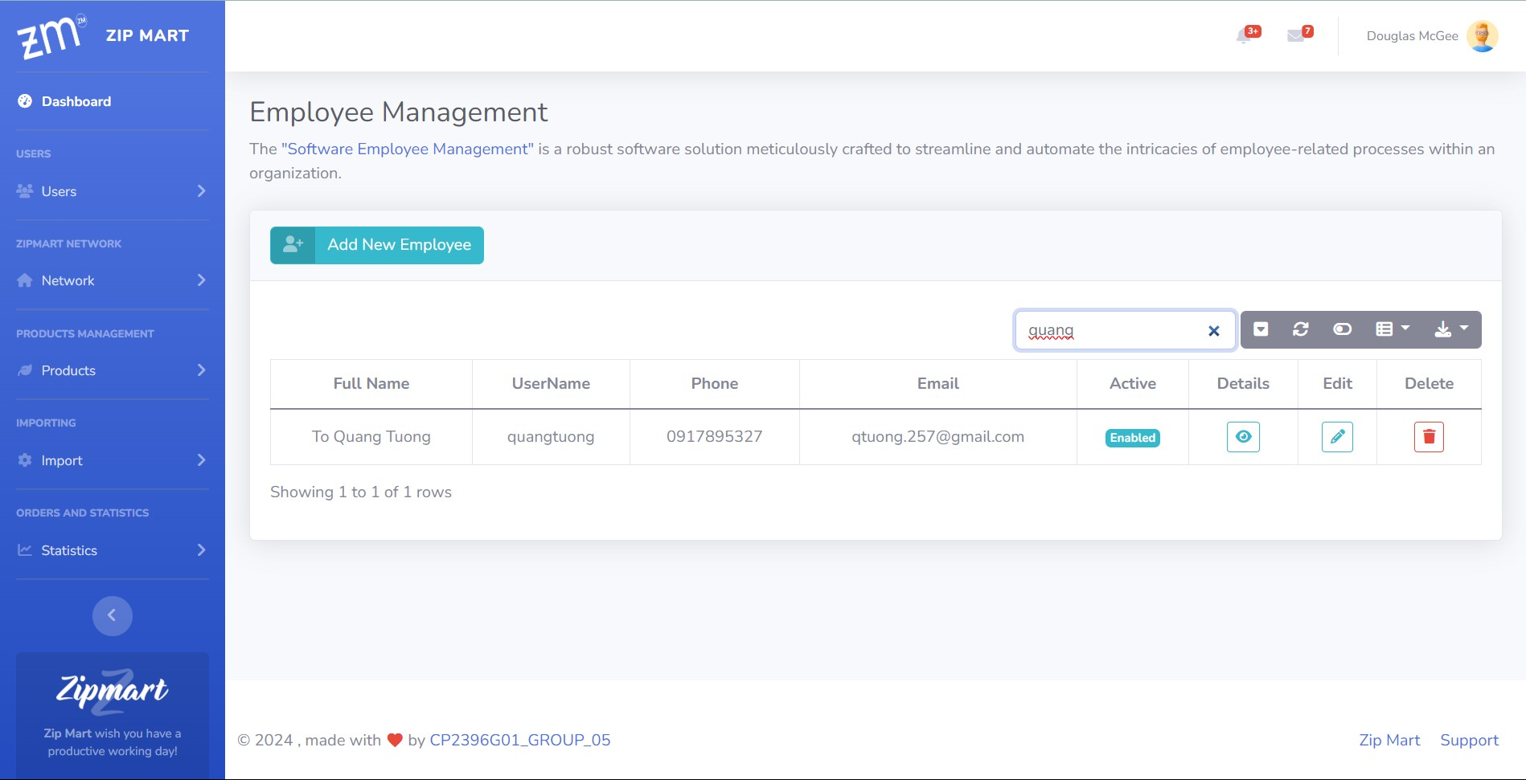

1. **Login**

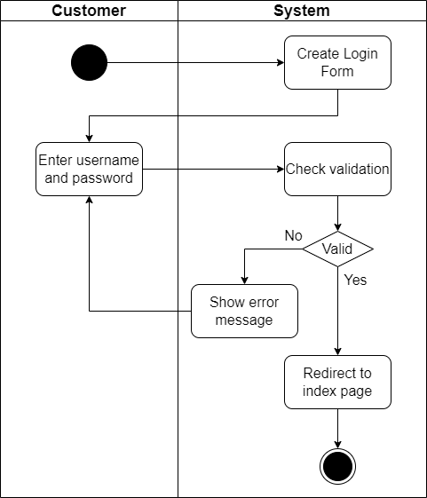

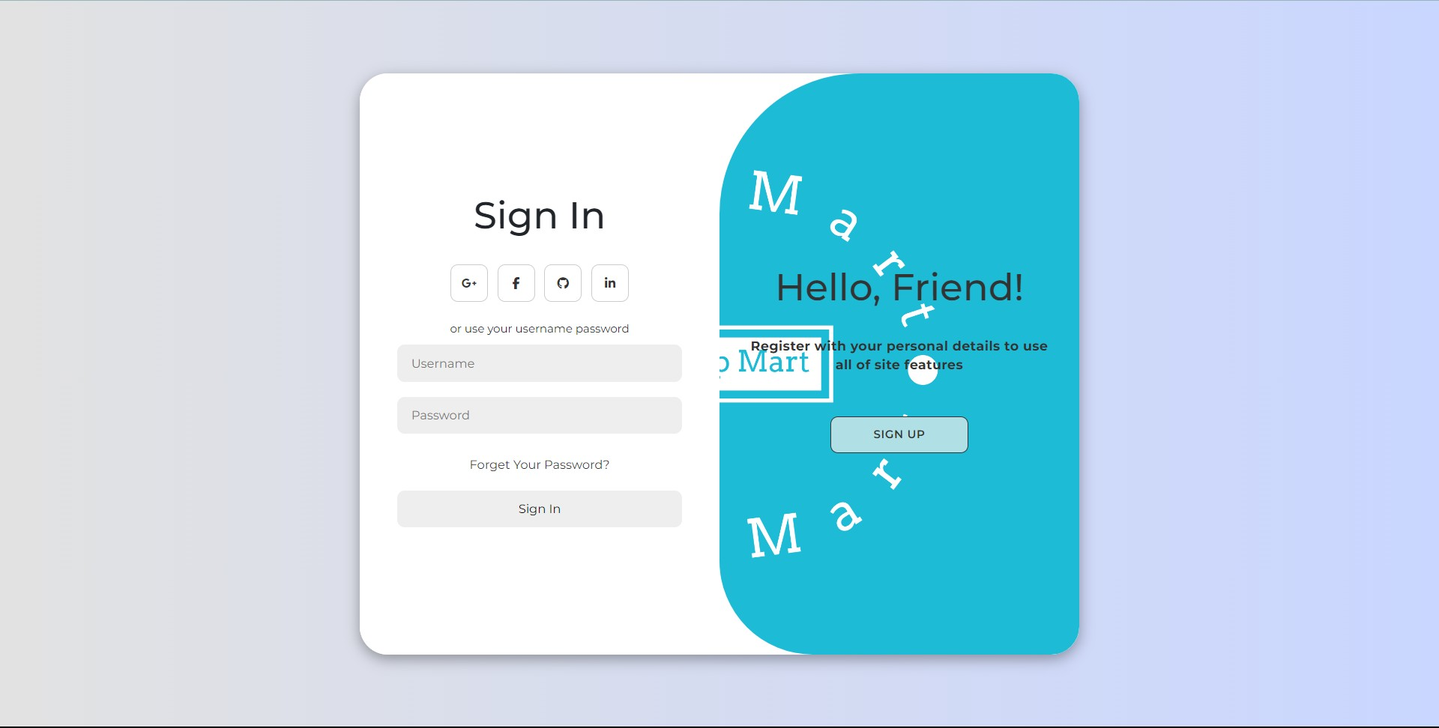

1. **Register**

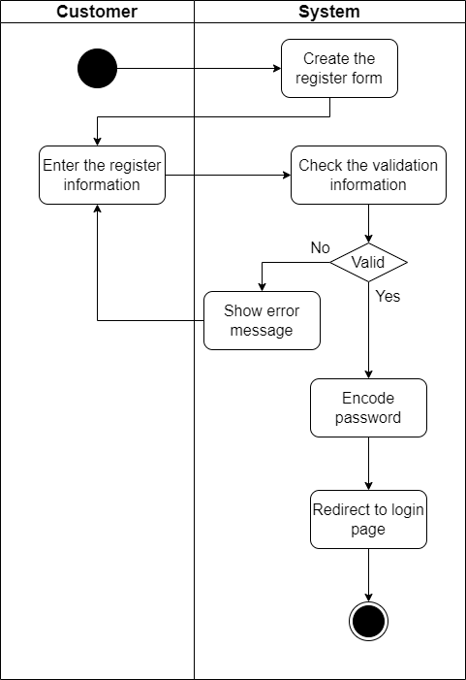

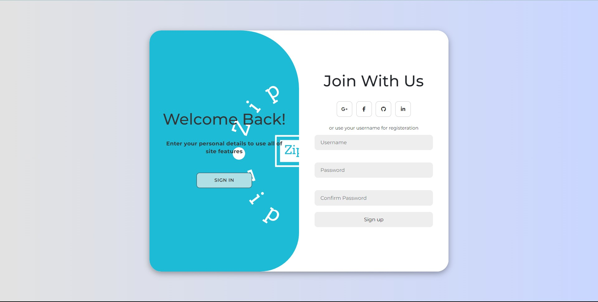

1. **Order**
   1. **Create Order**

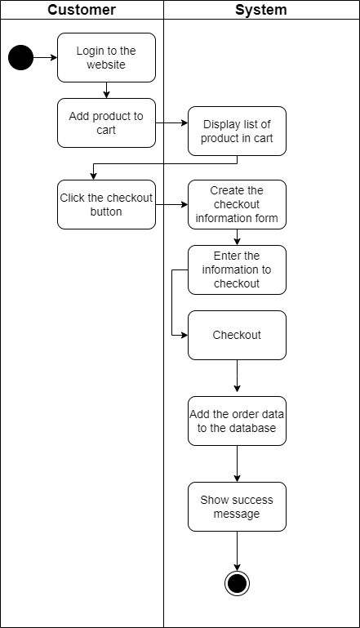

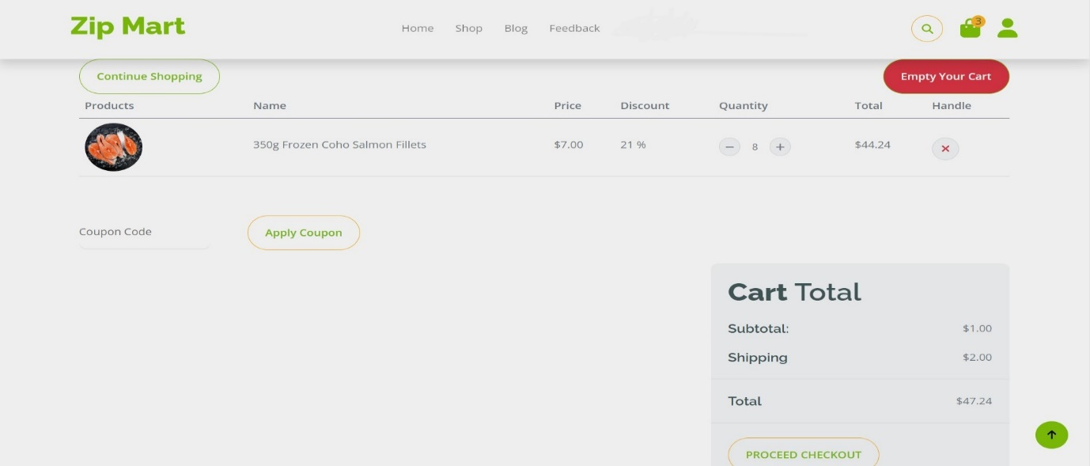 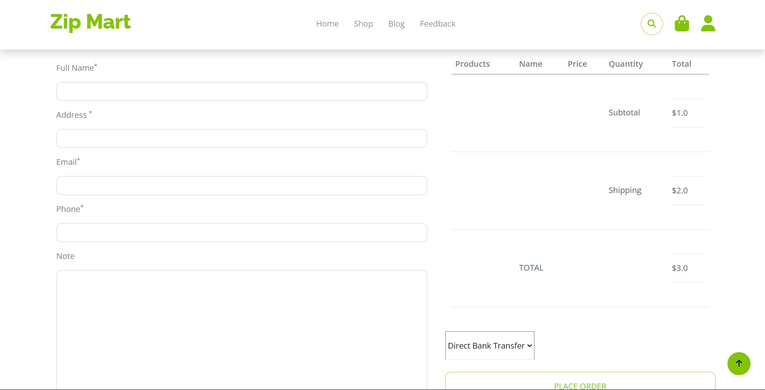

* 1. **View and confirm Order**

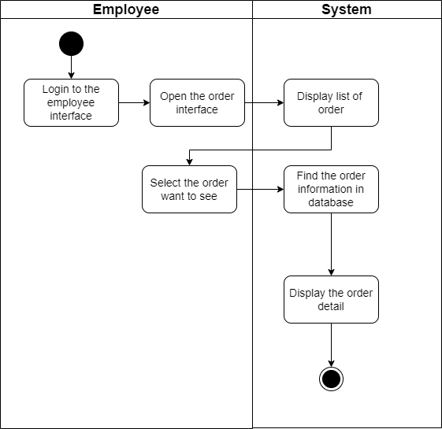

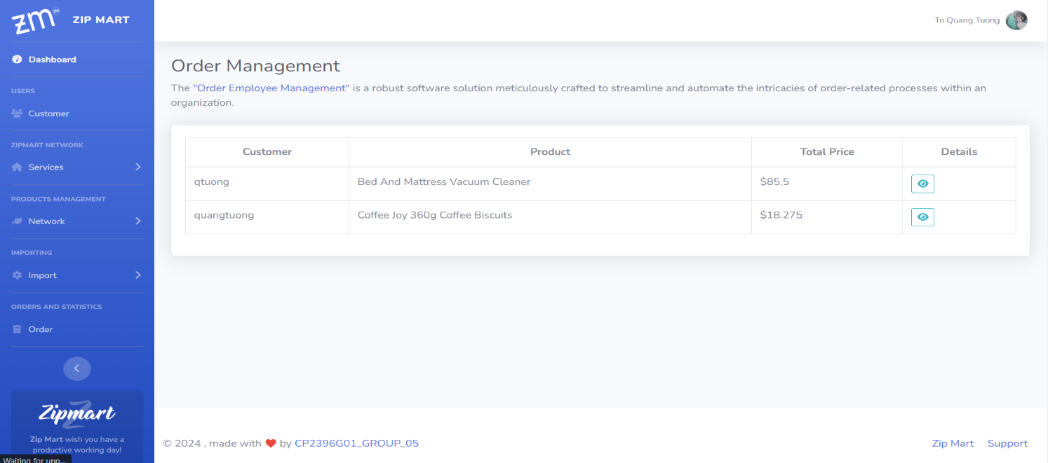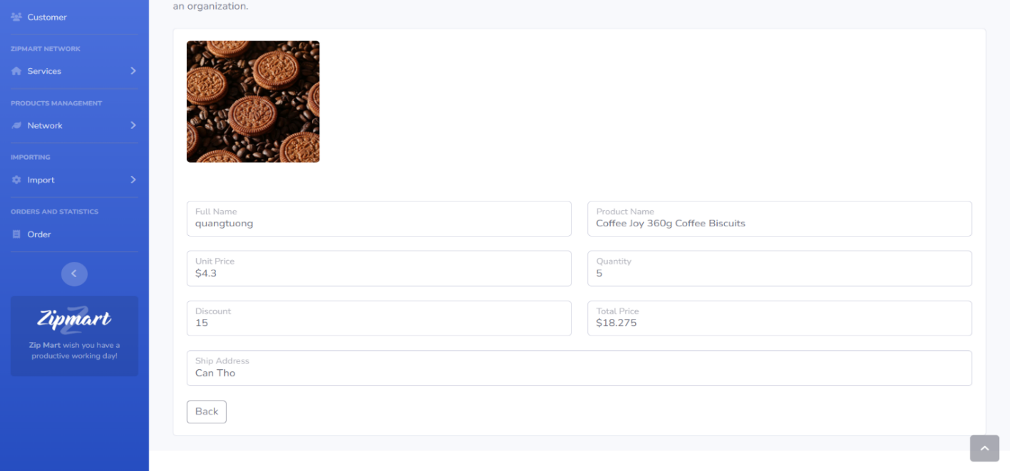

* 1. **History Order**

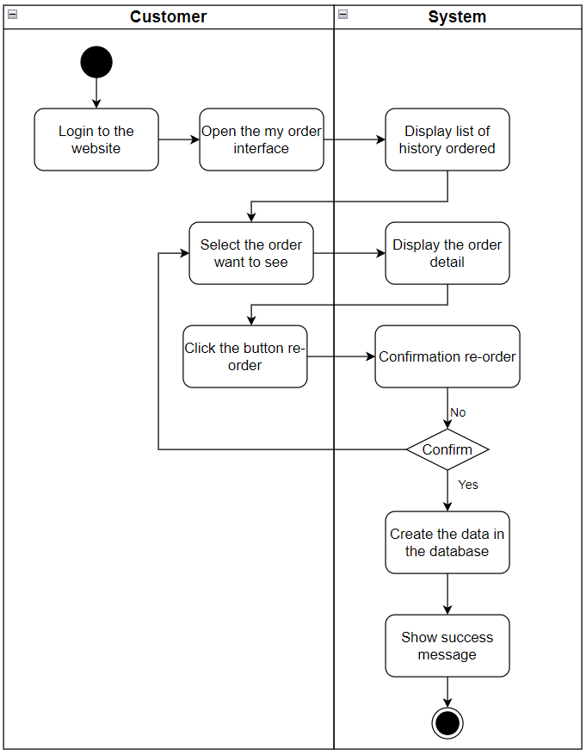

* 1. **Statistics Order**

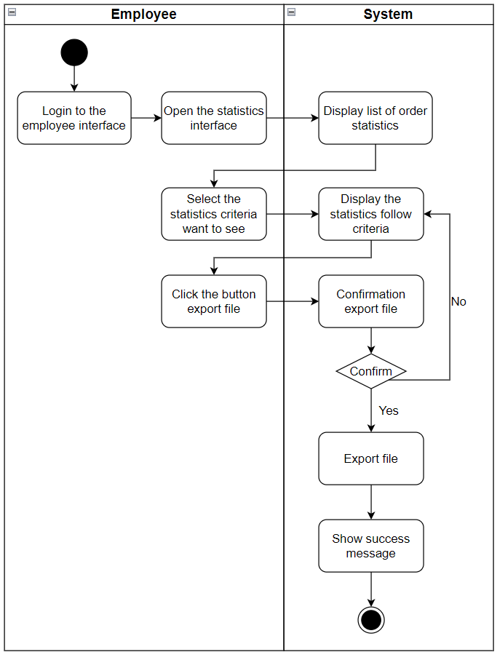

1. **Brand** 
   1. **Add Brand**

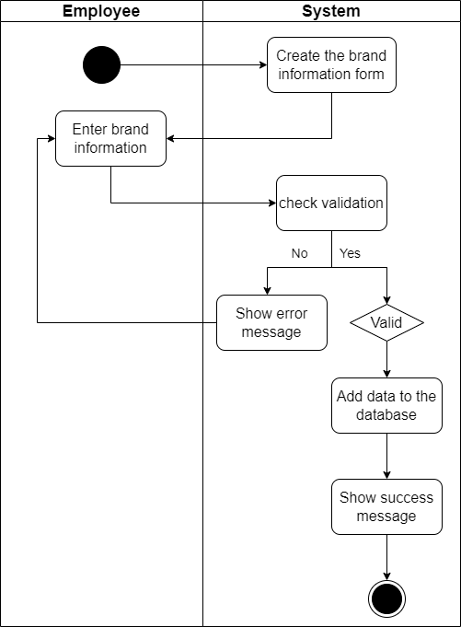

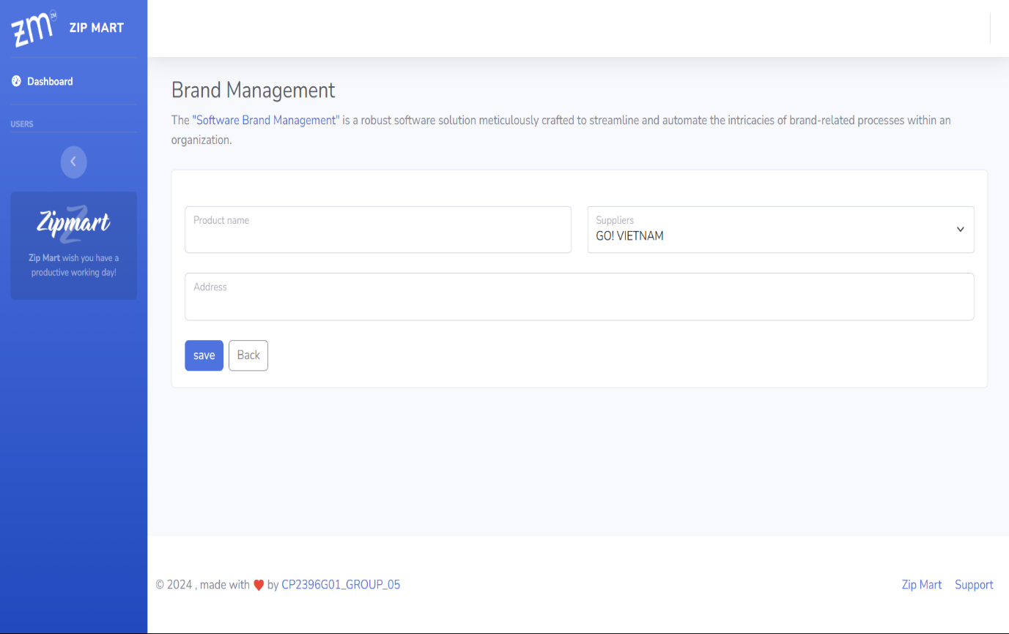

* 1. **Update Brand**

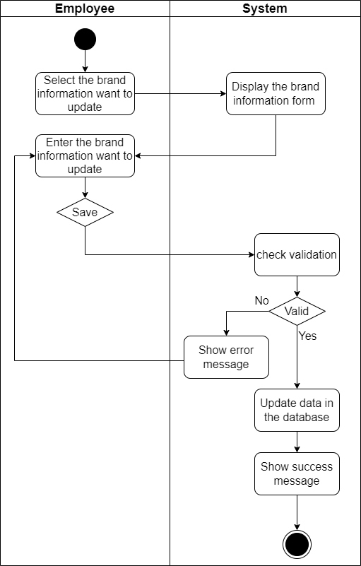

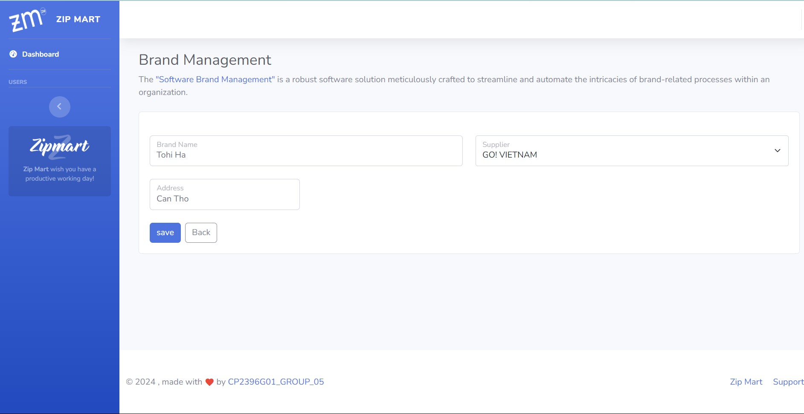

* 1. **View Brand**

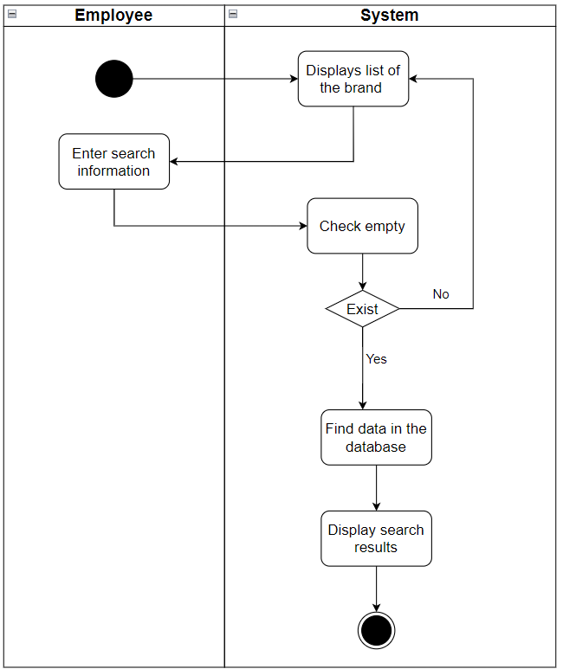

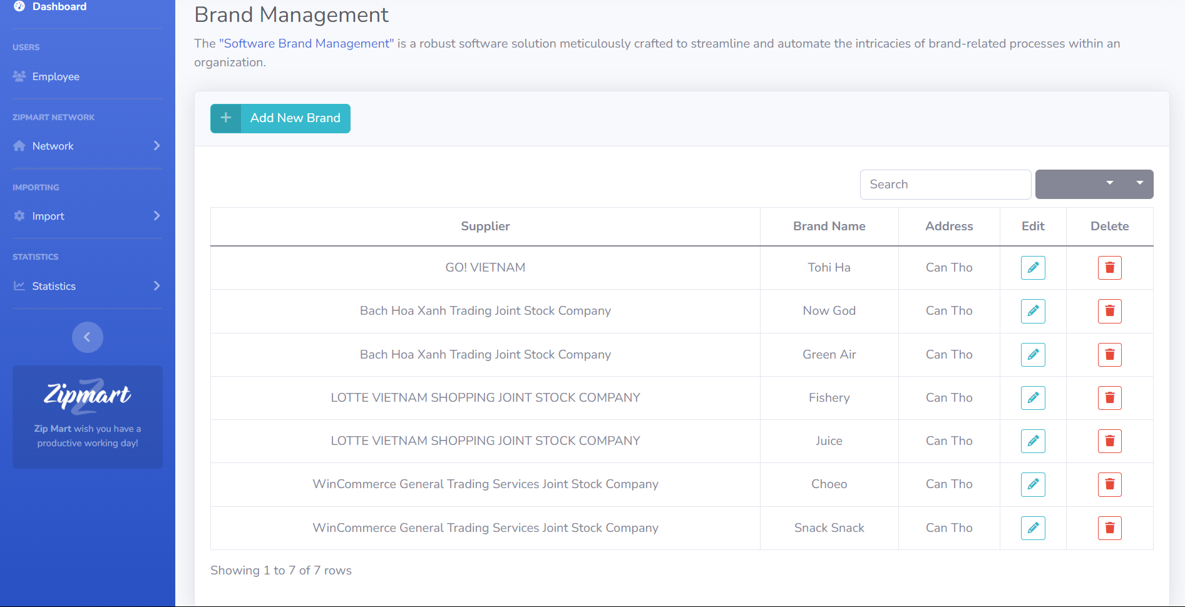

1. **Branch**
   1. **Add Branch**

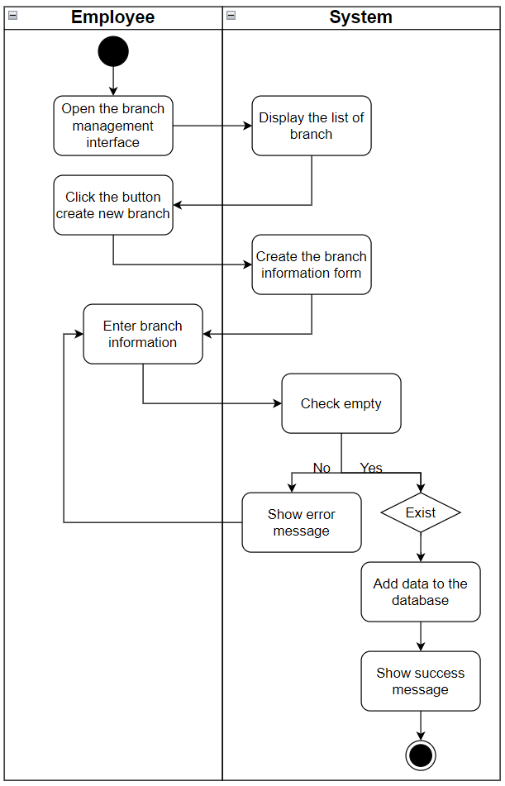

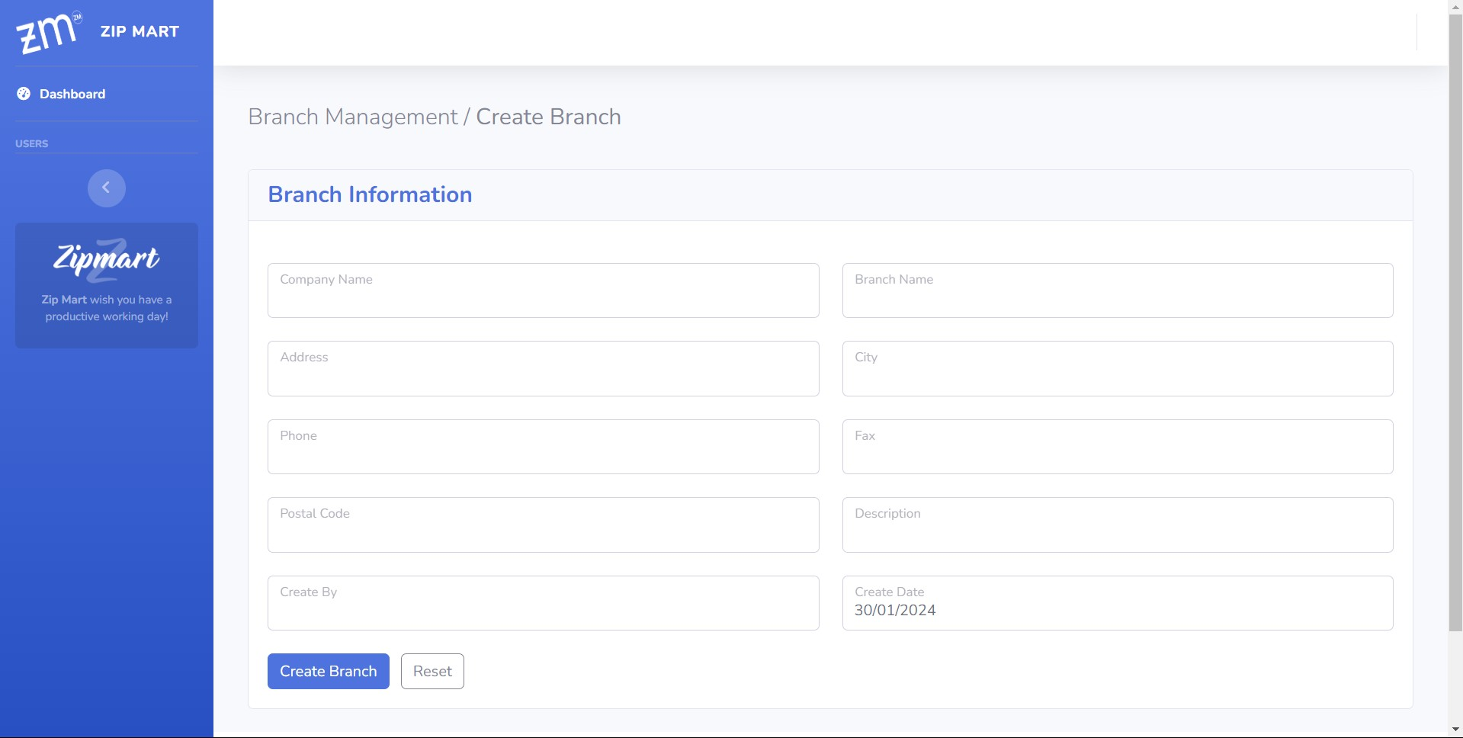

* 1. **Update Branch**

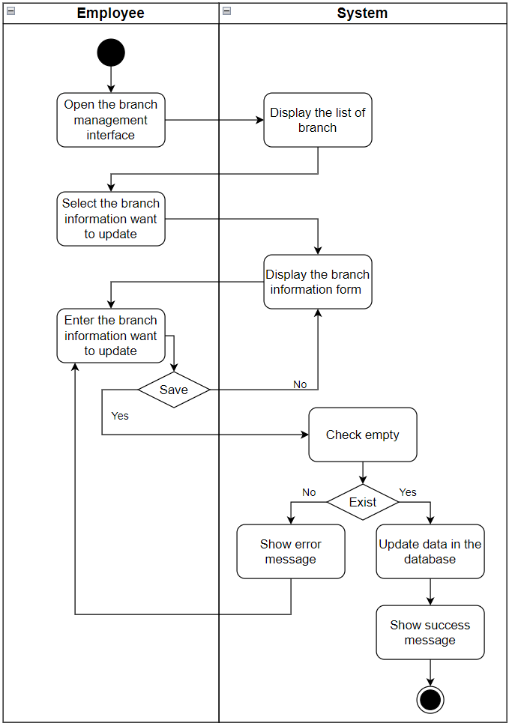

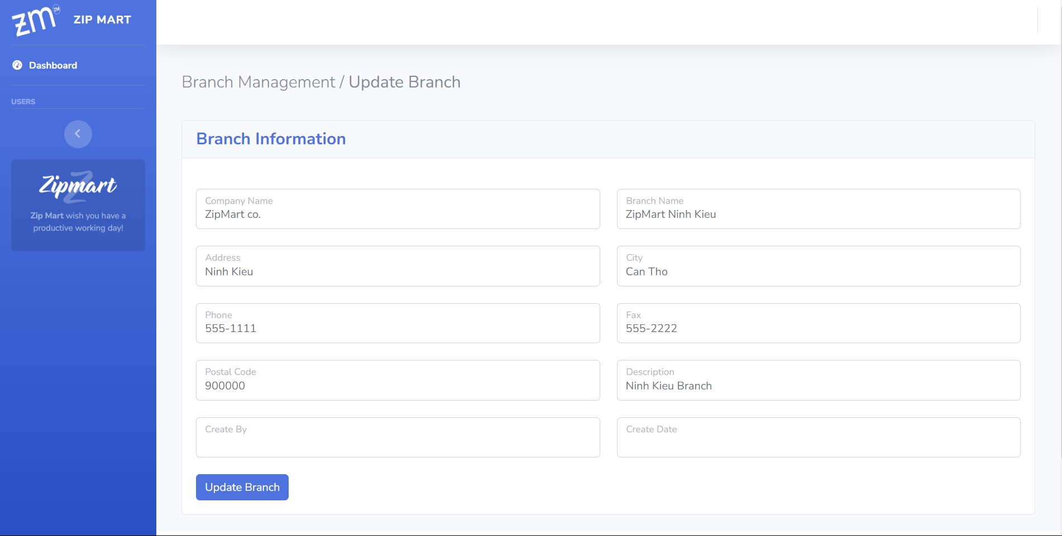

1. **Customer**
   1. **Create Customer**

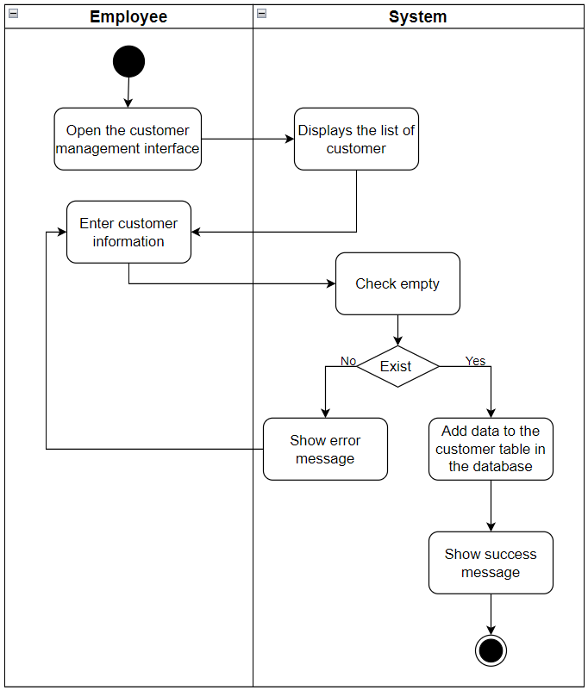

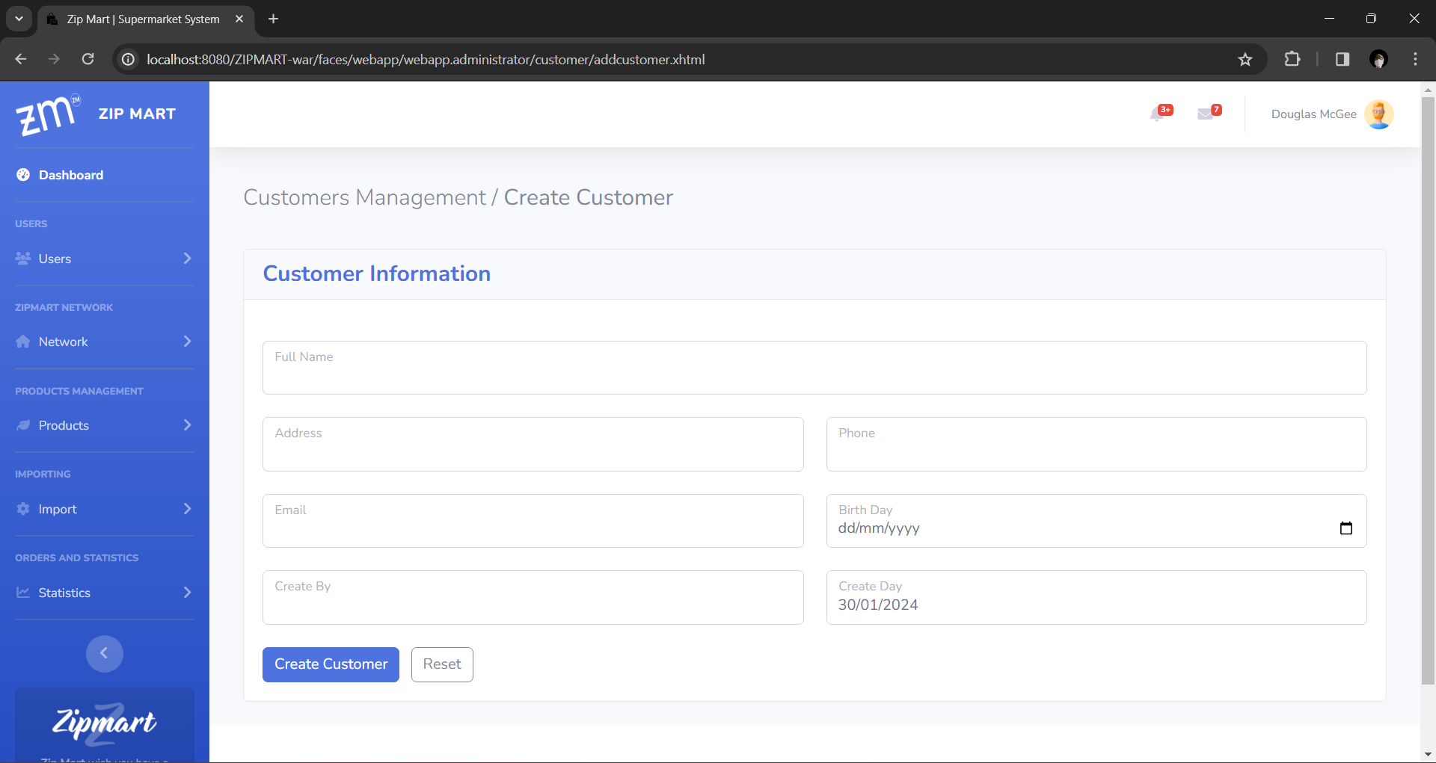

* 1. **Update Customer**

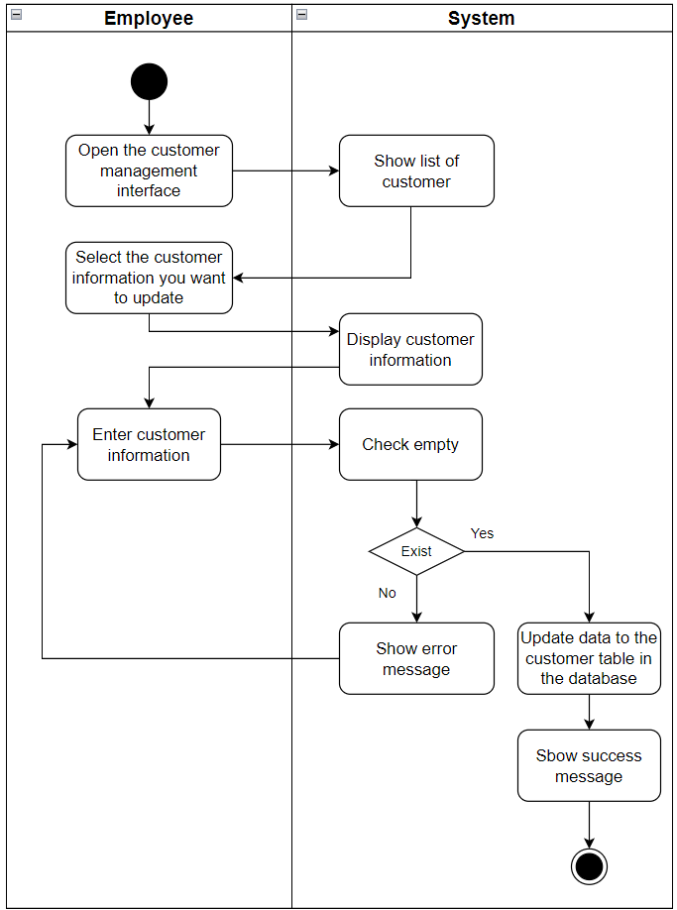

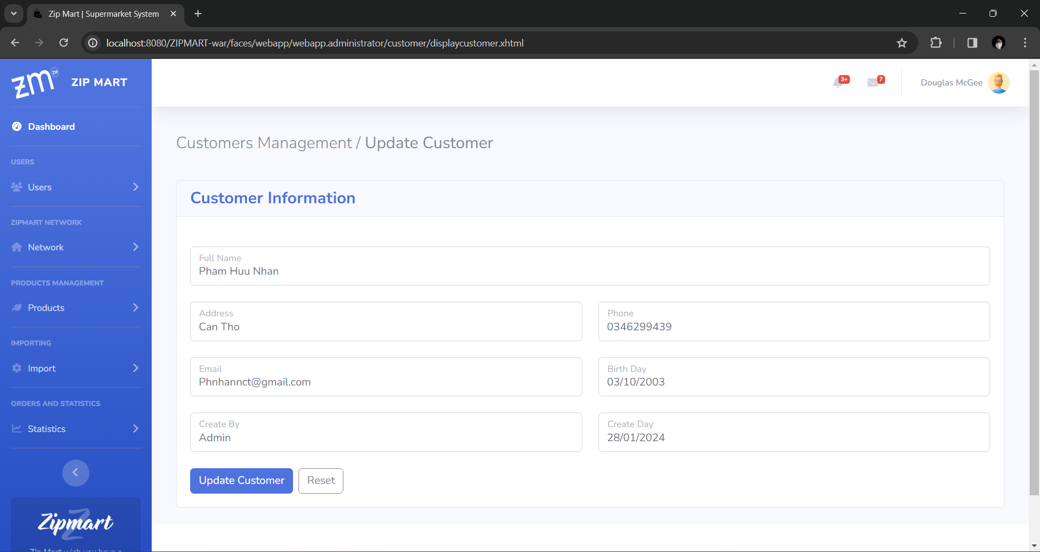

* 1. **Delete Customer**

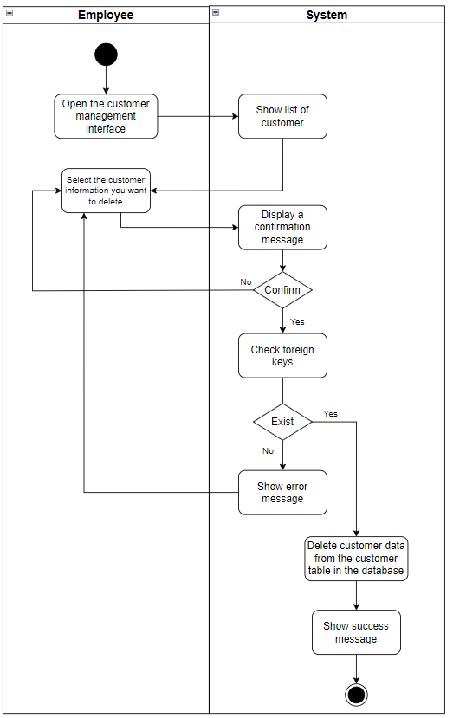

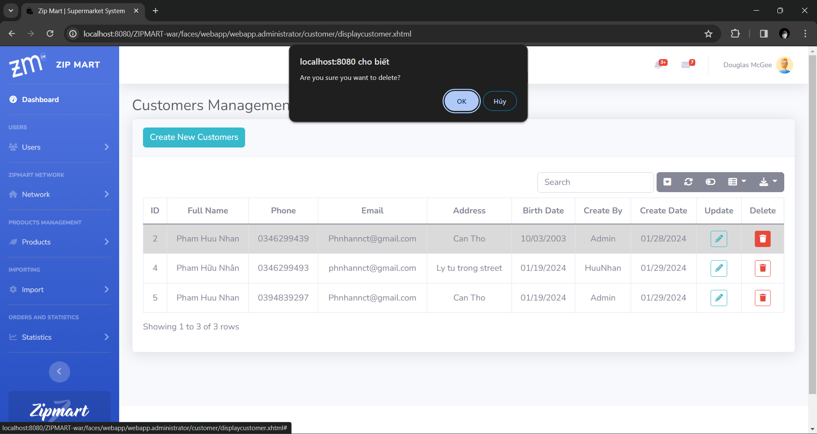

1. **Blog**
   1. **Create Blog**

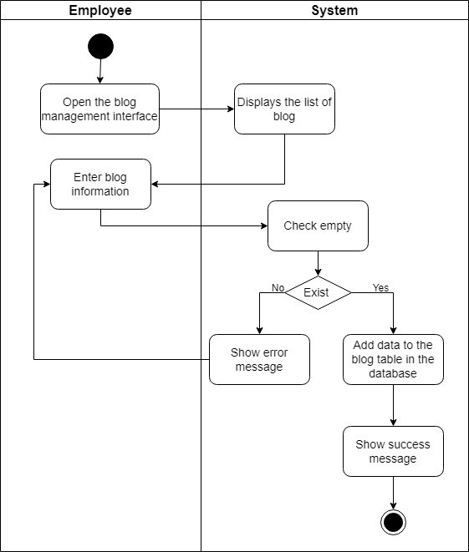

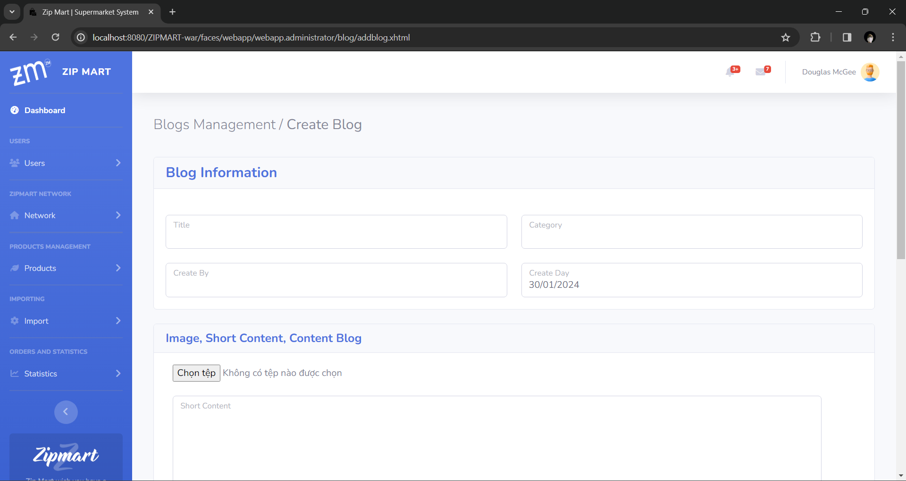

* 1. **Update Blog**

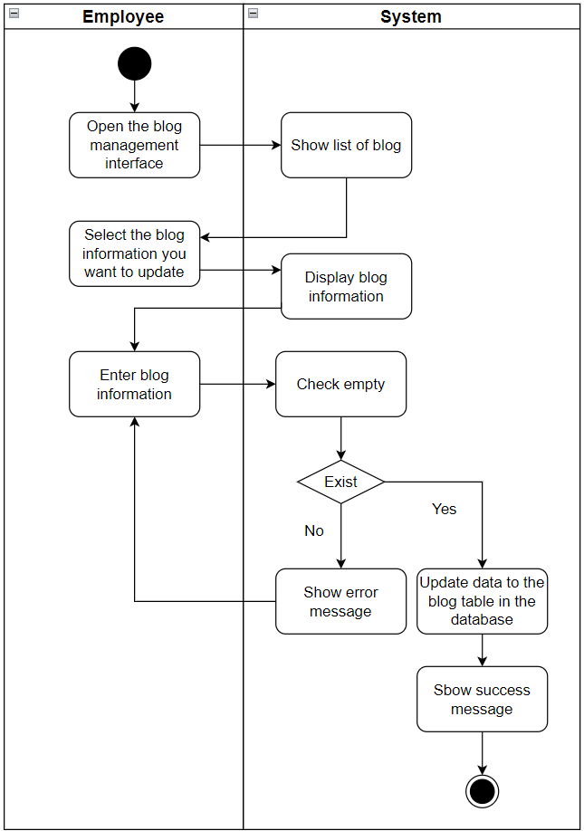

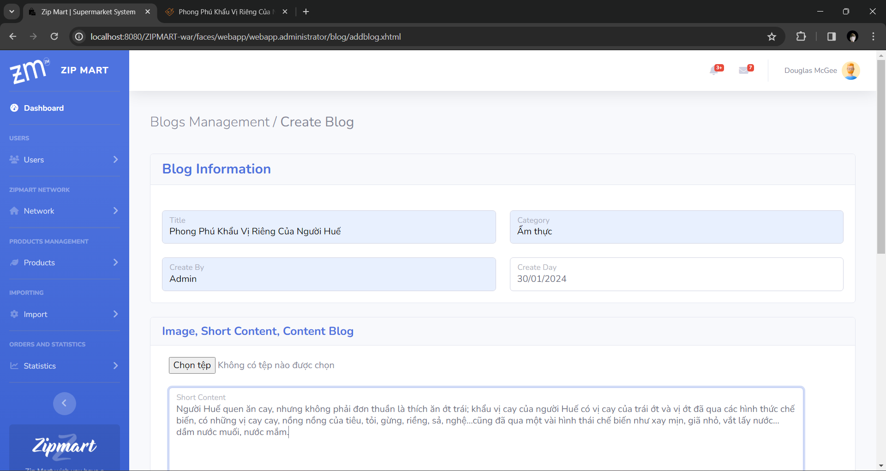

* 1. **Delete Blog**

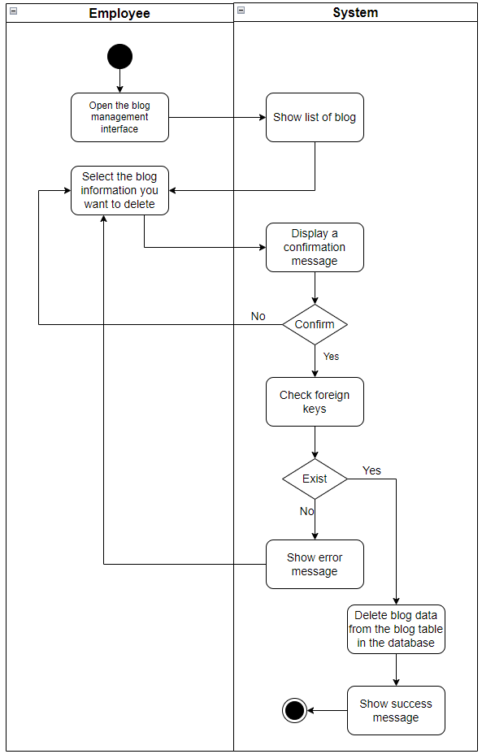

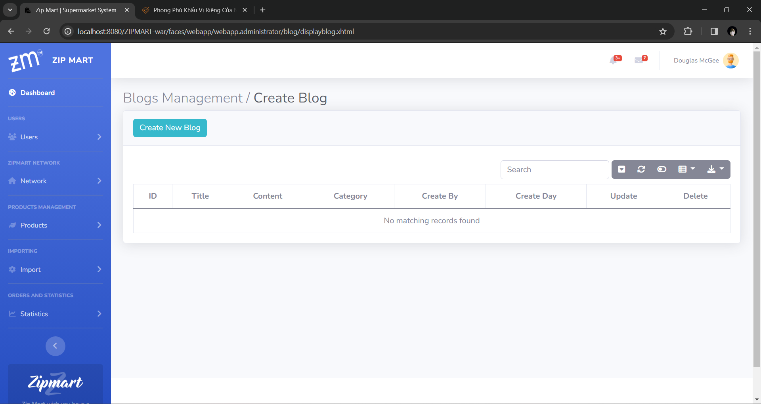

1. **Feedback**
   1. **Create Feedback**

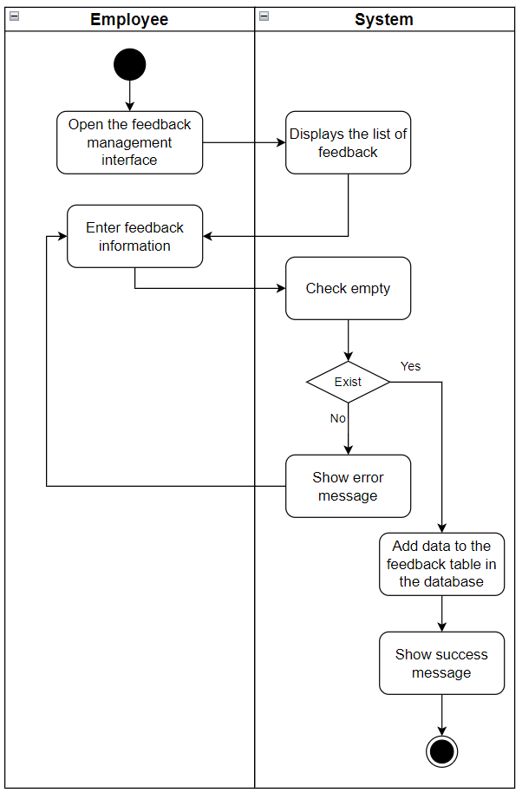

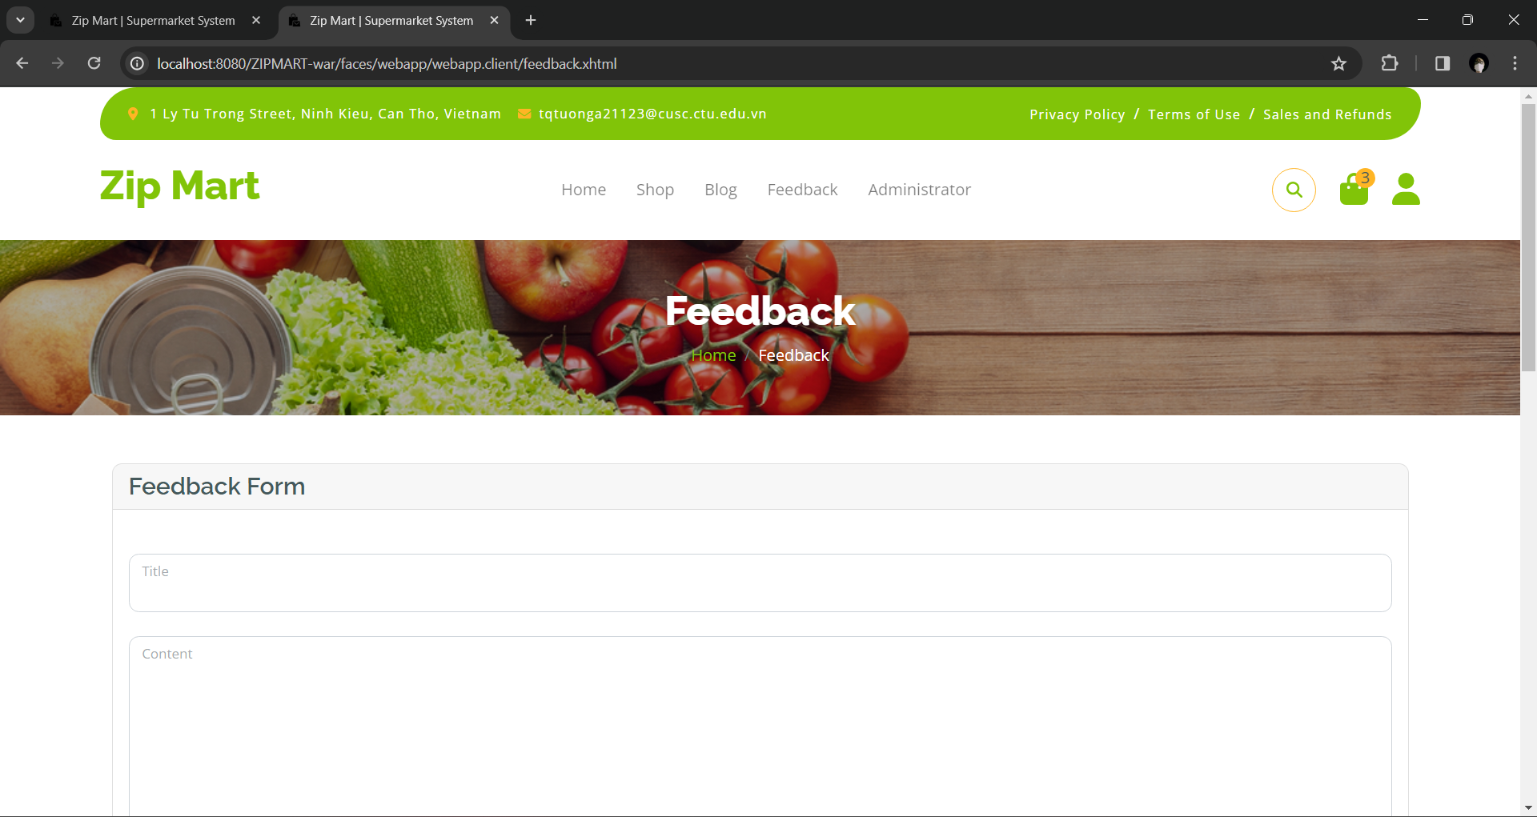

* 1. **Update Feedback**

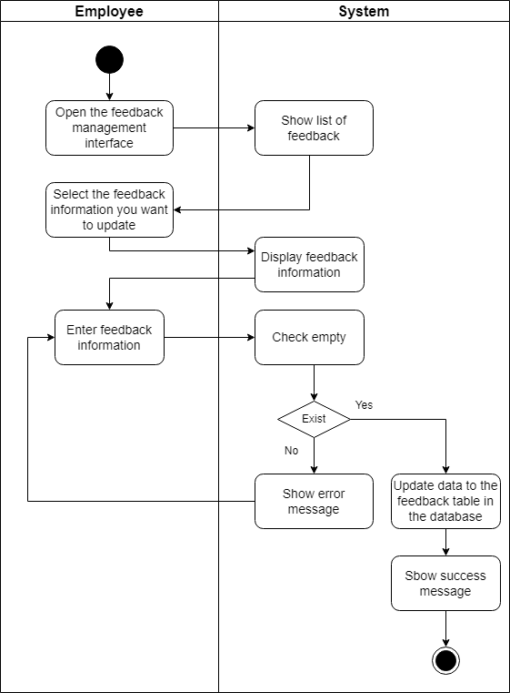

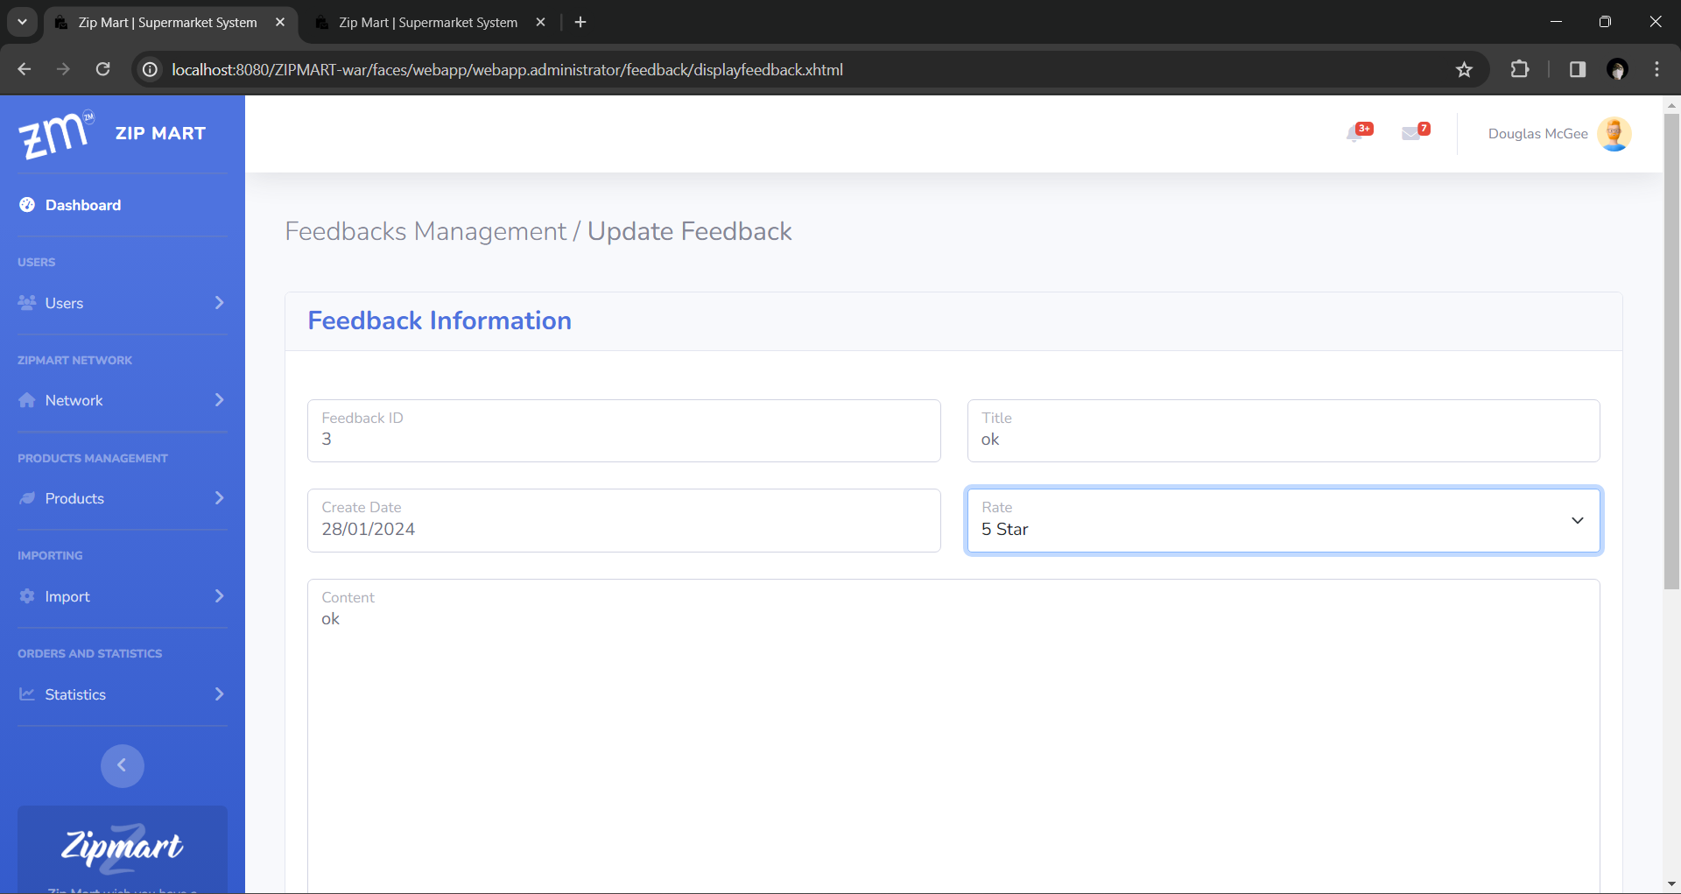

* 1. **Delete Feedback**

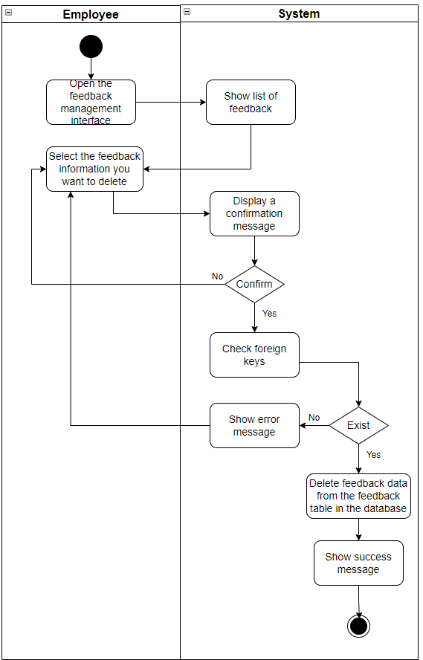

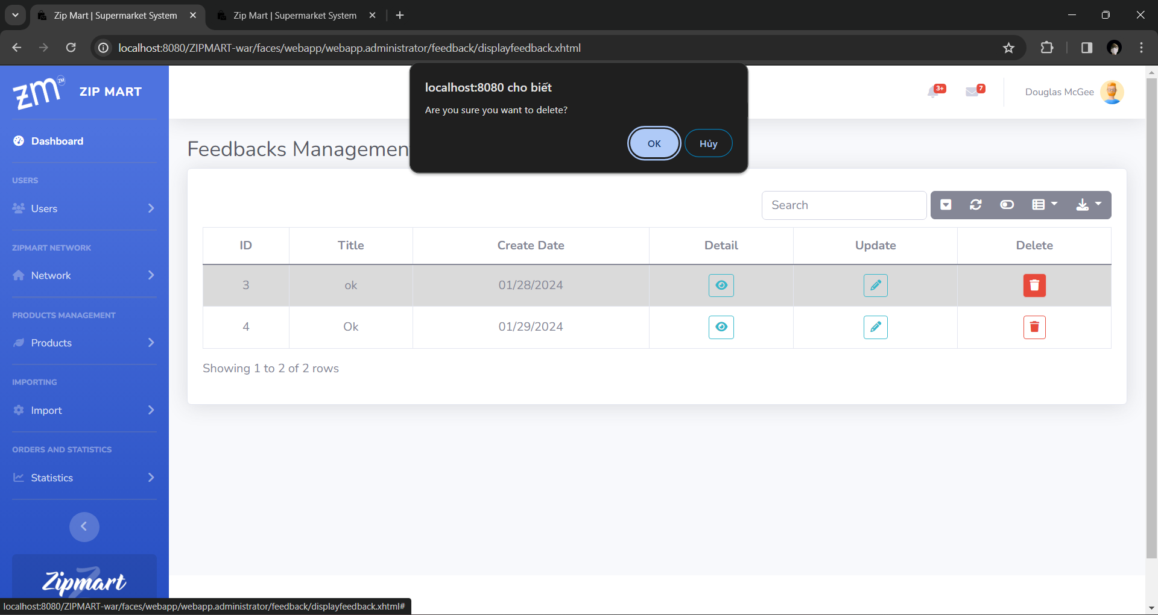

1. **Import**
   1. **Add Import**

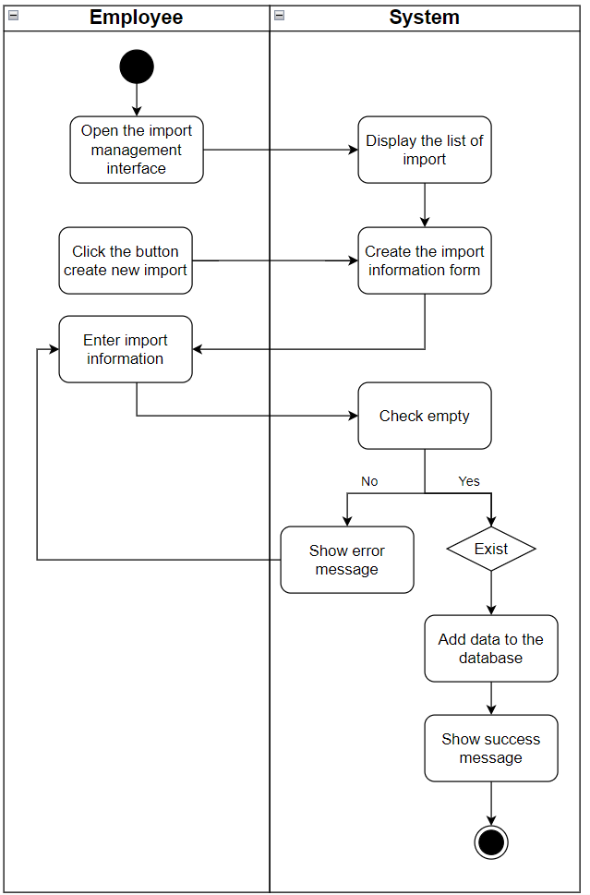

* 1. **View Import**

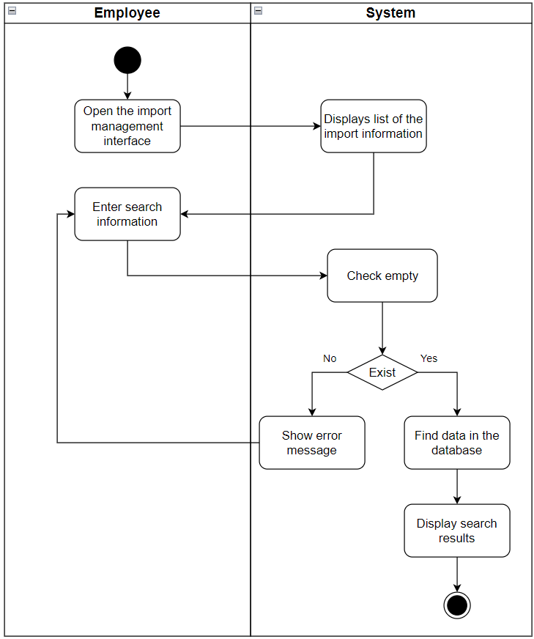

* 1. **Statistics Import**

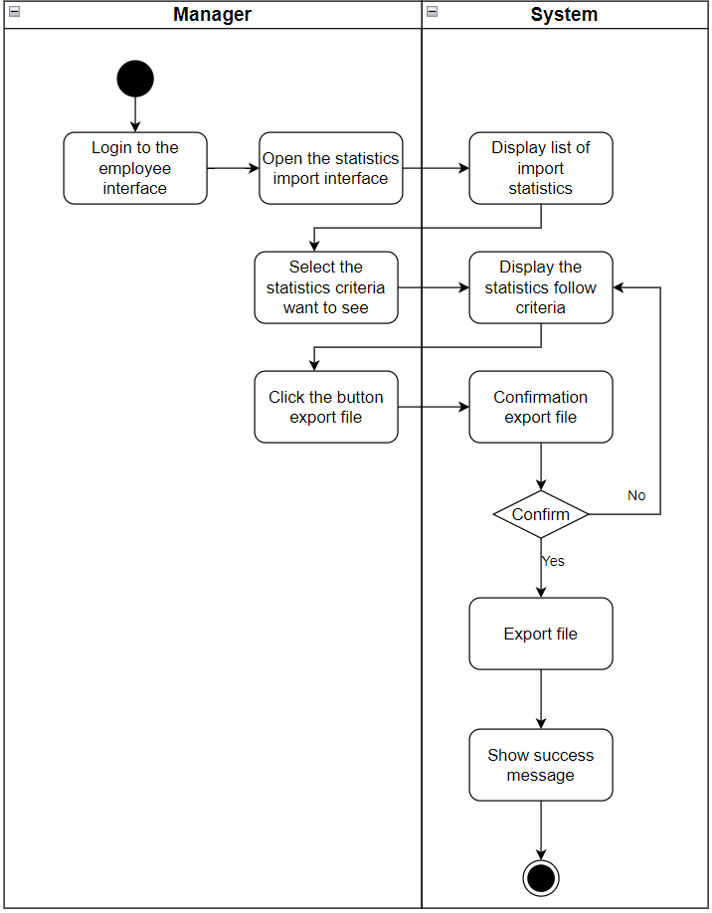

* 1. **Confirm Import**

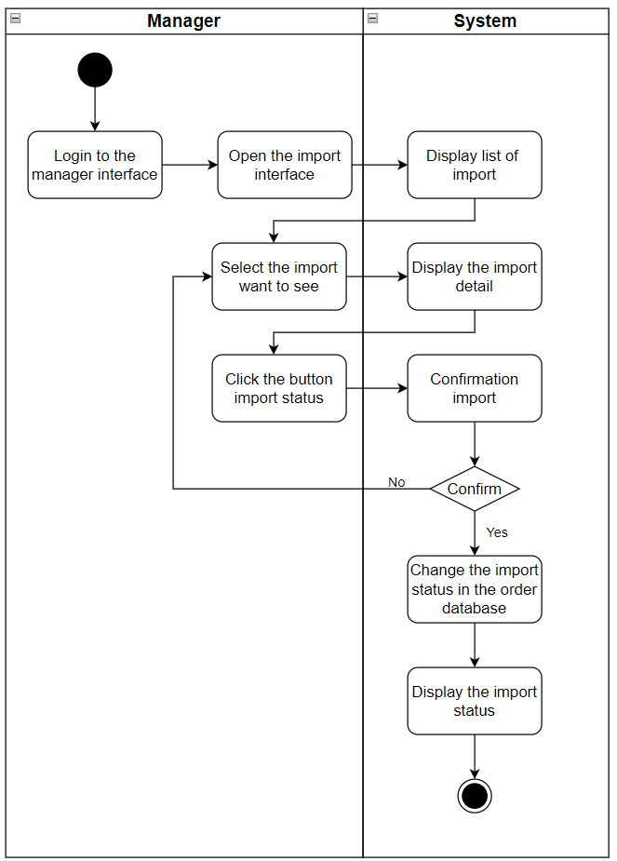

1. **Product**
   1. **Create Product**

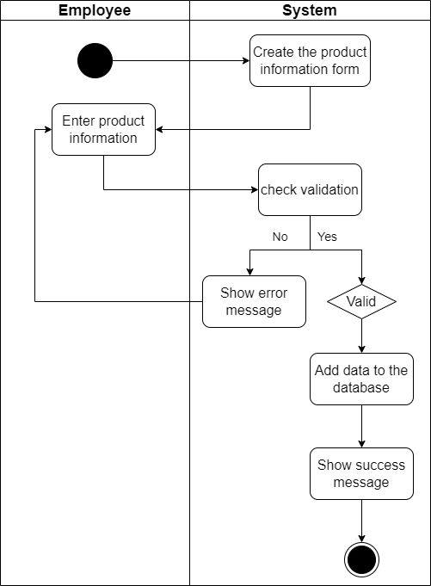

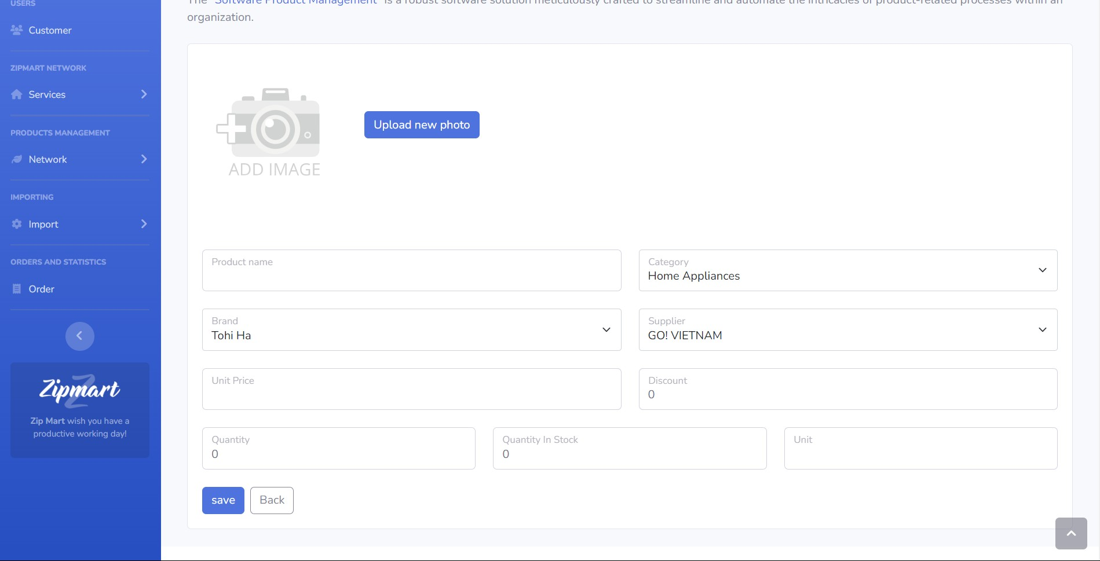

* 1. **Update Product**

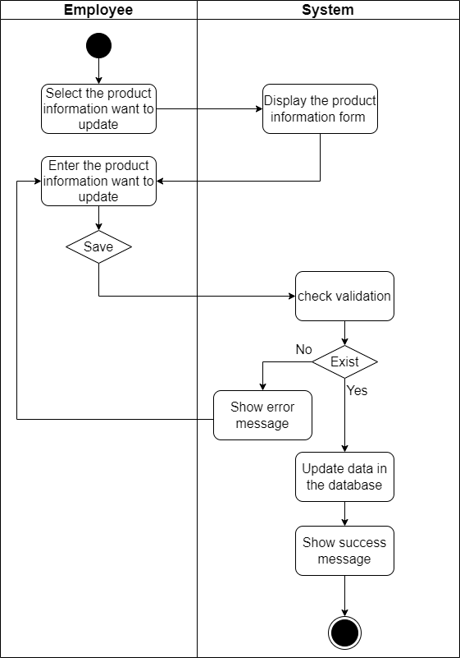

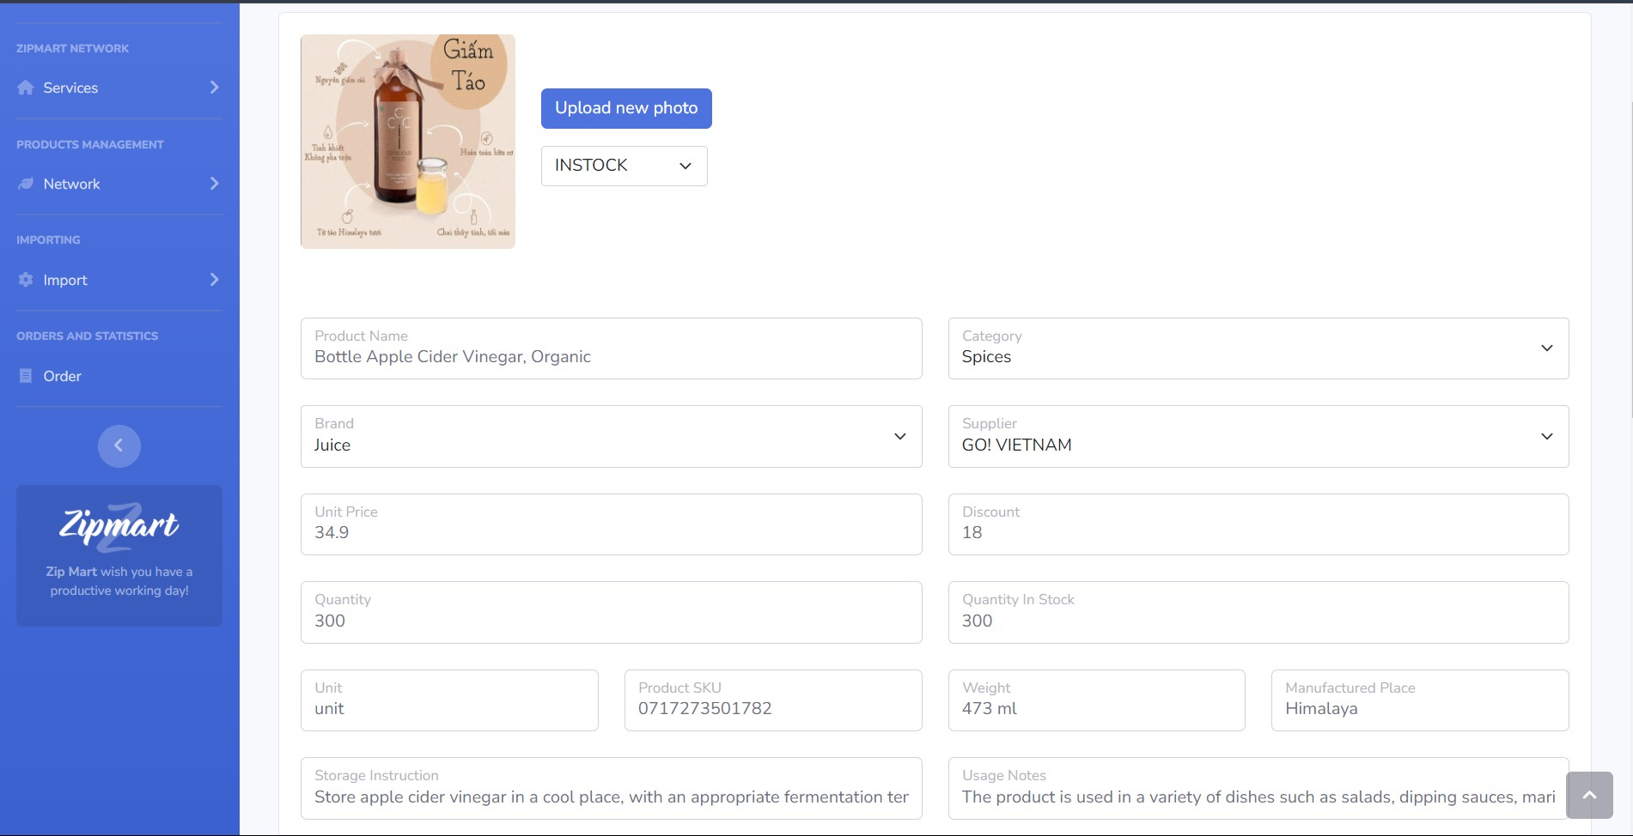

* 1. **View Product**

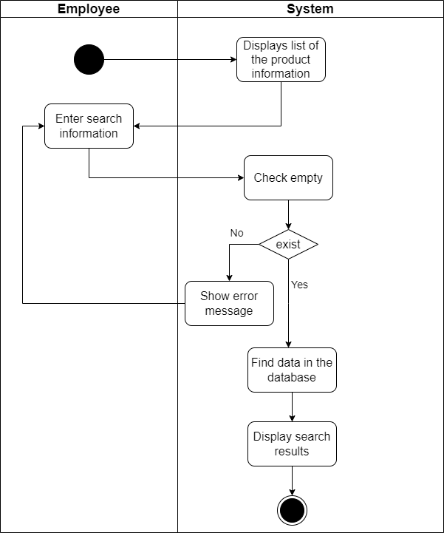

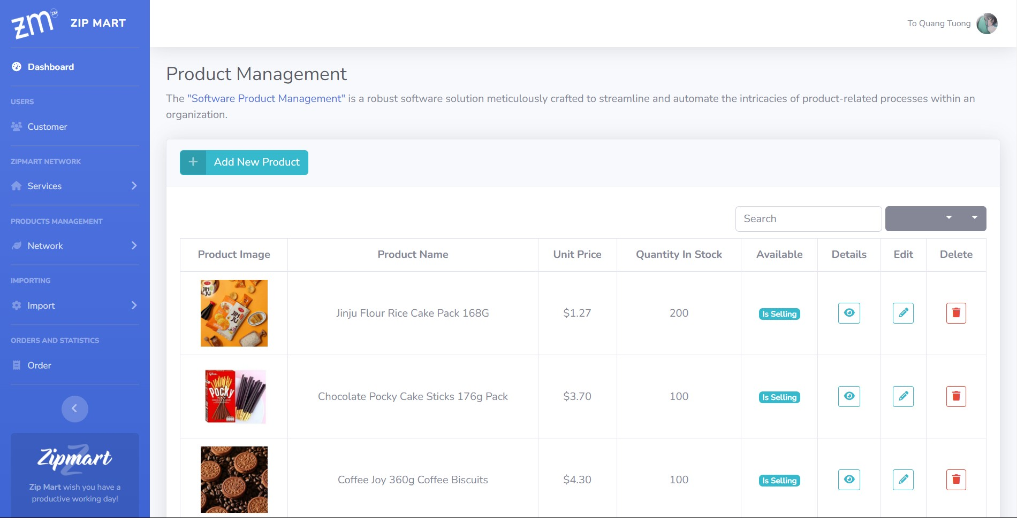

* 1. **Delete Product**

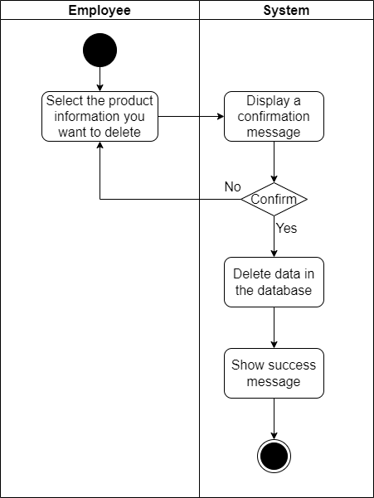

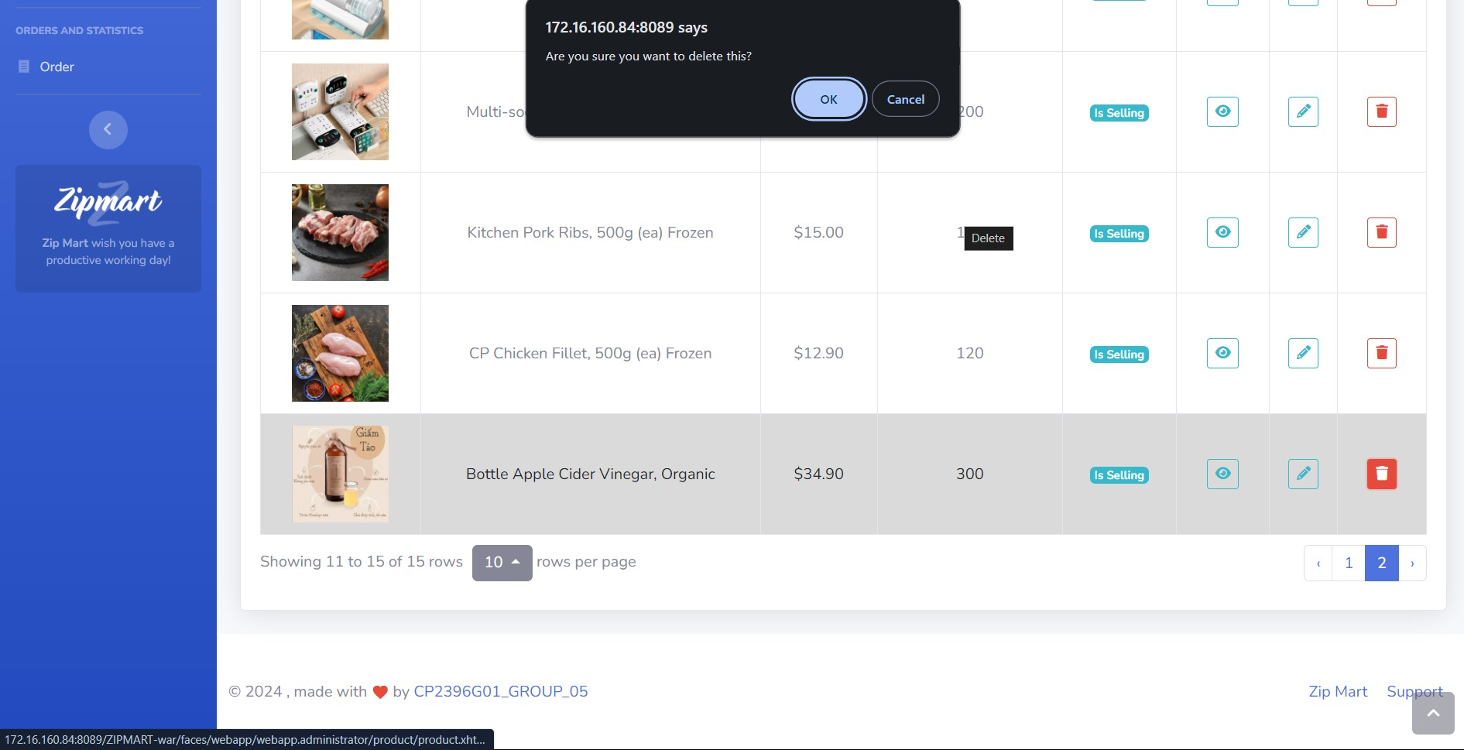

1. **Supplier**
   1. **Create Supplier**

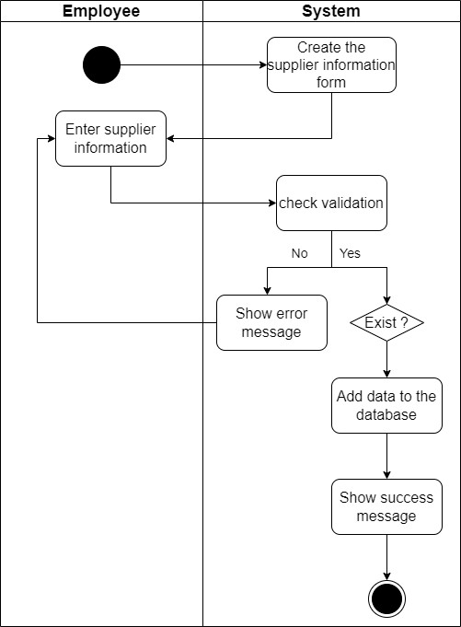

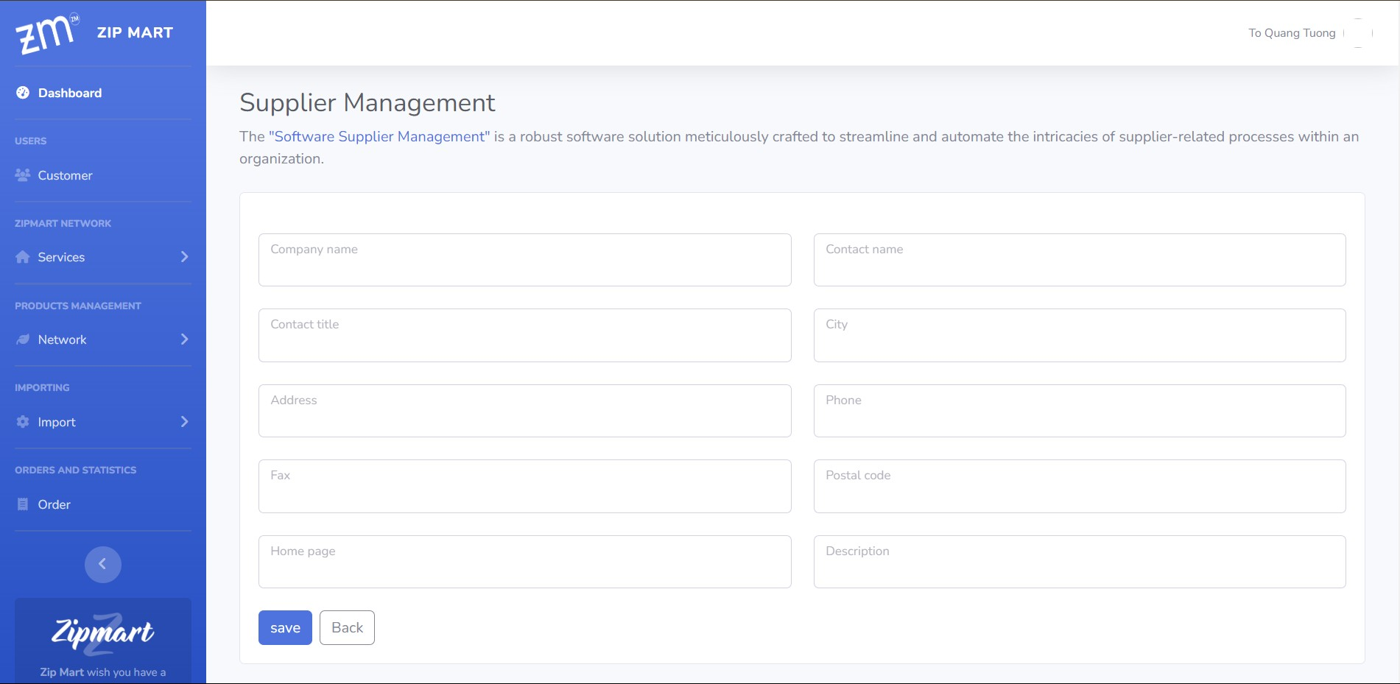

* 1. **Update Supplier**

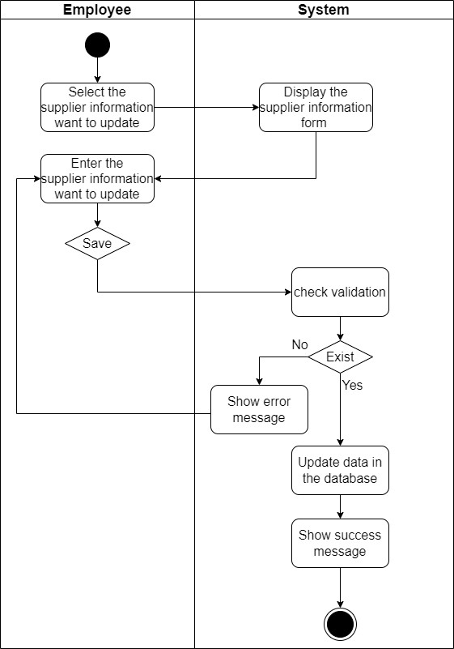

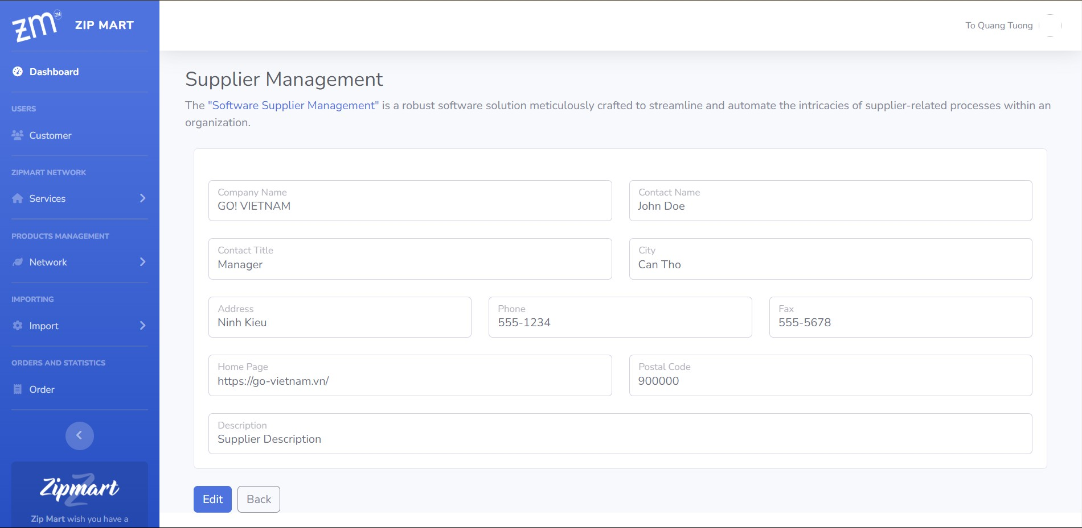

* 1. **View Supplier**

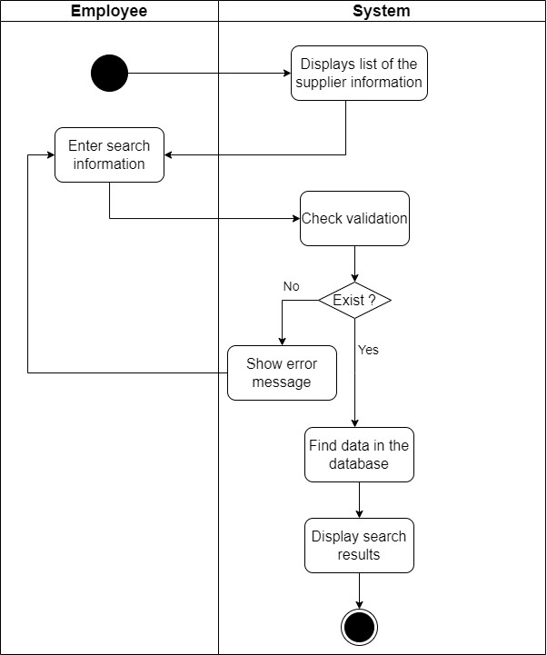

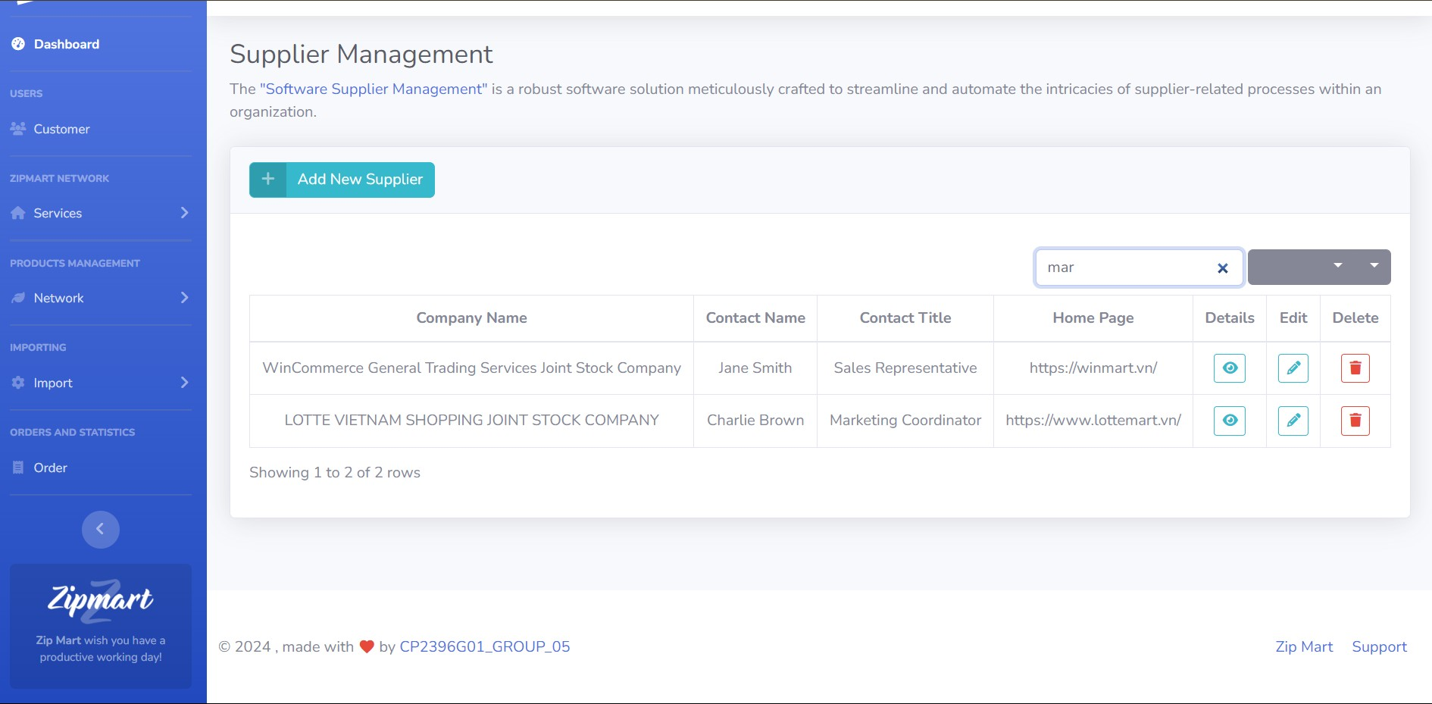

* 1. **Delete Supplier**

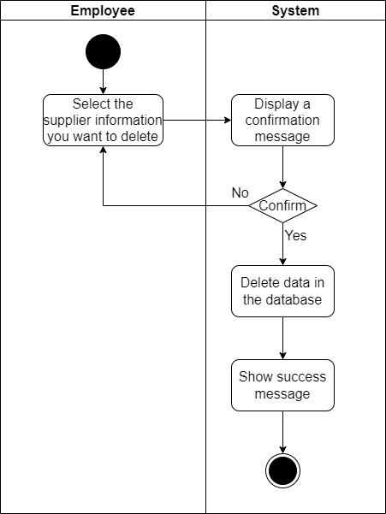

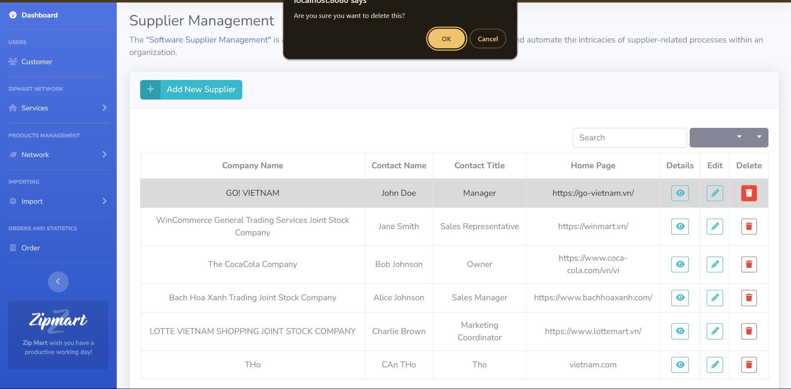

**CODING STANDARDS DOCUMENT**

1. **Programming Standards**

● File Type: Java Source (. java), Java bytecode(.class)., Html source code (.xhtml)

● File Name: We use Gnumake to build our software.

● File Organization: A file consists of sections that should be separated by blank lines and an optional comment identifying each section. Files longer than 2000 lines are cumbersome and should be avoided.

● Java Source Files:

● Beginning comments

● Package and Import statements(example: package cusc.cchc.controller; import java.awt.*; import java.net.*).

● Class and interface declarations.

1. **Standards for code writing style**

● Command line length: Avoid writing command lines longer than 80 characters.

● Braces: Opening curly brace "{"; must be placed at the end of the line and closing brace "}" must be placed on a new line.

● Indentation:

● After each command line starts the structure, the “level” is increased by 1 tab.

● After each command line ends the structure, the “level” is reduced by 1 tab.

● Command lines of the same "level" are indented equally.

● Equally spaced indented “levels”.

● Line break:

● Break after comma

● Interrupt before operator

● Interrupt conventions with higher precedence take precedence

● New line is indented by 2 tabs.

● Comments:

● Not adding a lot of comments will reduce the quality of the code.

● There are 4 types:

● Block Comments.

● Single-Line Comments.

● Trailing Comments.

● End-Of-Line Comments

1. **Standards for declaring Variables**

**-** It is recommended to use each declaration on one line.

● Number Per Line: example(int level; // indentation level, int size; // size of table)

● Object currentEntry: // currently selected table entry

● Placement:example( void MyMethod() { int int1; // beginning of method block if (condition) { int int2; // beginning of "if" block ... } }).

1. **Standards for Function Declarations**

Command code:

* Use curly braces “{}” even if there is only 1 command line.
* Structure control should use a space between simple lock and unlock control “(”, to parse them with a function call.
* The function name is followed by a comma () and the function statement is enclosed in {}.

Example:

class Example extends Object {

int var1;

int var2;

Sample (int i, int j) {

ivar1 = i;

ivar2 = j;

}

int emptyMethod () {}

... }

* Methods are separated by a blank line.

1. **Other Standards**

* Naming must be meaningful.
* Similar names should be avoided.
* Don't use confusing names.
* Abbreviations should be avoided.
* Does not contain special characters and the _ is only used for constants.
* Should separate 2 blank lines for each part of the file.
* How to name files based on common conventions:

Management function + Main content of the file + Contains programming function

**TASK SHEET**

**Project Title: Zip Mart**

|  |  |  |  |  |
| --- | --- | --- | --- | --- |
| **No.** | **Task** | **Actual Days** | **Teammate Name** | **Status** |
|  | Form 01:  Problem Definition Document | 07/11 | Pham Hieu Tho | Complete |
|  | Form 02A:  Customer Requirements Specification (CRS) | 07/11 | Pham Huu Nhan  Pham Hieu Tho  To Quang Tuong | Complete |
|  | Form 02B: Customer Acceptance Criteria | 15/11 | Pham Huu Nhan | Complete |
|  | Form 03:  Project Plan | 08/11 | To Quang Tuong | Complete |
|  | Form 04: Architecture & GUI Standard of Application | 08/11 | Pham Hieu Tho | Complete |
|  | Form 05: Interface Design Document | 15/11 | Pham Hieu Tho | Complete |
|  | Form 06: Database Design Document | 20/11 | Pham Hieu Tho,  To Quang Tuong | Complete |
|  | Form 07: Process Design Document | 20/11 | Pham Huu Nhan, Pham Hieu Tho, To Quang Tuong | Complete |
|  | Form 08: Coding Standards Document | 23/11 | Pham Hieu Tho | Complete |
|  | Form 09: Task Sheet | 26/11 | To Quang Tuong | Complete |
|  | Form 10:  Testing Document | 1/12 | To Quang Tuong | Complete |
|  | Form 11: Project Review | 5/12 | To Quang Tuong | Complete |
|  | Form 12: Final Check List | 7/12 | To Quang Tuong | Complete |
|  | Manager Employee | 15/11 | To Quang Tuong | Complete |
|  | Login and Register System | 19/11 | To Quang Tuong | Complete |
|  | Manager Supplier | 25/11 | Pham Hieu Tho | Complete |
|  | Manager Order | 5/12 | To Quang Tuong | Complete |
|  | Manager Branch | 20/11 | Pham Huu Nhan | Complete |
|  | Manager Product | 19/11 | Pham Hieu Tho | Complete |
|  | Manager Customer | 1/11 | Pham Huu Nhan | Complete |
|  | Manager Blog | 9/11 | Pham Huu Nhan | Complete |
|  | Manager Feedback | 25/11 | Pham Huu Nhan | Complete |
|  | Manager Category | 25/11 | Pham Huu Nhan | Complete |
|  | Manager Brand | 29/11 | Pham Hieu Tho | Complete |

**TESTING DOCUMENT**

|  |  |  |  |  |
| --- | --- | --- | --- | --- |
| **ID** | **Test Case Name** | **Task** | **Result** | |
| **Expected** | **Actual Result**  Pass/Fail-Comments |
|  | Add Employee  Details | Enter employee details:  Name Employee: To Quang Tuong  Username: quangtuong  Password: 123  Email: qtuong.257@gmail.com  Address: CT  Brith:07/25/2003  Phone:09845632 | Record is added to the database | Pass |
| Add Employee  Details | Enter employee details:  Username: quangtuong  Email: qtuong.257@gmail12.com  Address: CT  Brith:07/25/2003  Phone:09845632 | Check valid email, exist username  Show message error | Fail |
| Update Employee | Find employee id and update information of employee id | Information is updated in database | Pass |
| Delete Employee | Change status of employee from enable to disable and hide on the board | Status change in the database | Pass |
|  | Add Products | Images Product: upload file  Product Name: Test  Select Category: Fishery  Select Brand: Sea Fod  Select Supplier: Lotte  UnitPrice: 11.2  Discount:0  Quantity:120  Quantity In Stock: 130  Unit: gam | Record is added to the database | Pass  SHOW ON THE BOARD |
| Images Product: upload file  Product Name: Test  Select Category: Fishery  Select Brand: Sea Fod  Select Supplier: Lotte  UnitPrice: 11.2  Discount:0  Quantity:120  Quantity In Stock: 130  Unit: gam | Notice without data | Pass |
| Update Product | Find product id and update information of product id | Data is updated in database | Pass |
| Delete Product | Change status available of product from enable to disable and hide on the board | Available is change in the database | Pass |
|  | Register | Enter information to register:  Username: quangtuong  Password: 123  Confirm password: 123 | Encode password and add data to database | Pass |
| Login | Enter username and password to login:  Username: quangtuong  Password:123 | Check password and redirect to index page | Pass |
| Login | Enter wrong username or password:  Username: quangtuong  Password: 789 | Notice incorrect username or password | Pass |
| Edit profile | Enter information to update:  Fullname: To Quang Tuong  Email: qtuong.257@gmail.com  Phone Number: 0917895327  Address: Can Tho  Select gender: Male  Birthday: 07/25/2003 | Find by customer id and update data in the database | Pass |
| Change Password | Enter old password and new password:  Old password: 123 New password: 456 | Change and encode new password and update in the database | Pass |
|  | Order | Add product to cart and enter information to order product | Display order successful and add data in to the database | Pass |
|  | Brand | -Add brand: enter information to add brand Name: a  Supplier: Lotter  Address: Can Tho  -Edit brand: enter information to update  Name: b  Supplier: Lotter  Address: Can Tho  -Delete brand | -Add/ Updated in to the database ans show on the board.  -Display the message can not delete because have supplier | Pass |
|  | Supplier | -Add brand: enter information to add brand Company Name: Lotte  Contact Name: Lotter  Contact title: Manager  City: Can Tho  Address: Can Tho  Phone: 0917895327  Fax: 44556673  Postal code: 90000  Description: Can Tho  -Edit brand: enter information to update  Company Name: a  Contact Name: Lotter  Contact title: Can Tho  City: Can Tho  Address: Can Tho  Phone: 0917895327  Fax: 555666333  Postal code: 90000  Description: Can Tho | Add/ Updated in to the database ans show on the board. | Pass |
|  | Search Product | Enter name: product to search | File name product in the database. | Comment |

**PROJECT REVIEW**

|  |  |  |  |  |  |
| --- | --- | --- | --- | --- | --- |
| **Date** | **Project Plan Activity/Milestone** | **Work Specification** | **Status of the Activity** | **Remarks** | **Responsibility** |
| 8/11/2023 | Analyze requirements and assign work | All Form | Done | Good | All |
| 13/11/2023 | Discuss and address the functionality of the web | Web functionality | Done | Good | All |
| 1/12/2023 | Discussion and analysis of web traffic. | Use case | Done | Good | All |
| 24/11/2023 | Source code consolidation | Code | Done | Good | All |
| 21/12/2023 | Code manager | Code | Done | Good | All |
| 23/12/2023 | Make statistical code | Code | Done | Good | All |

**FINAL CHECKLIST**

| **S.No.** | **Aspect tested** | **Suggestion/Remarks** |
| --- | --- | --- |
|  | Have all the modules been property integrated and are they completely functional? | Yes |
|  | Are all the validations happening as specified in Process Design? | Yes |
|  | Have all Design and Coding standards been followed and implemented? | Yes |
|  | Whether or not the process of completion is met | Yes |
|  | Are project processes often experiencing errors that you cannot fix? | No |